**­DOCKER**

**Docker** is a tool designed to make it easier to create, deploy, and run applications by using containers. Containers allow a developer to package up an application with all of the parts it needs, such as libraries and other dependencies, and deploy it as one package.

**Docker** is a set of **platform as a service product** that uses OS-level virtualization to deliver software in packages called containers. Containers are isolated from one another and bundle their own software, libraries and configuration files; they can communicate with each other through well-defined channel

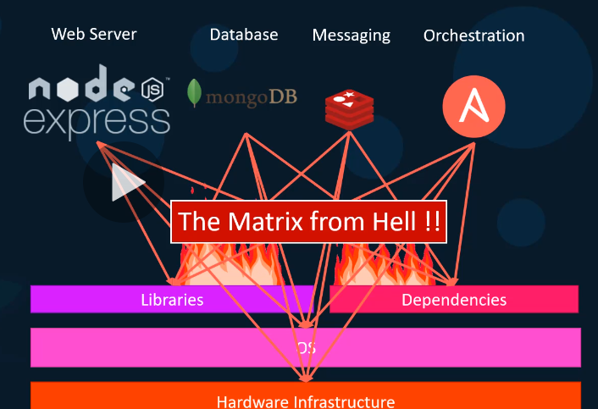**Why**?

1. Compatibility of underlying OS with application stack. (difficult to find an OS that is compatible with all application stack)
2. Whenever you upgrade any application, we need to check its compatibility with underlying infrastructure and other components (applications) (tough task).

Compatibility metrics issue usually referred as **The Matrix from the hell**

1. Helps new developers to set up environment quickly. (usually takes longtime to setup)
2. Making application to run in same way in different environment/OS

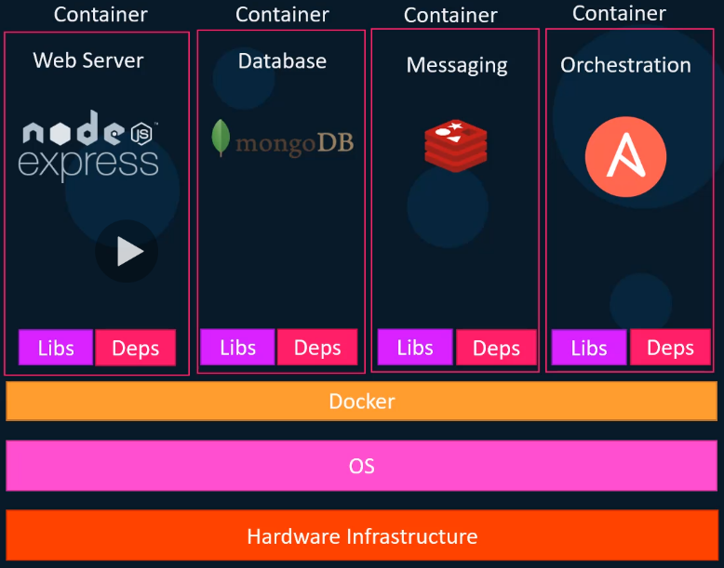**What it can do**?

1. We can run every component in separate container with its own libs and dependencies on the same VM/OS.
2. Create Docker configuration once and all our developers can now get started with simple Docker run command.
3. **Run each service with its own dependencies in separate containers**.

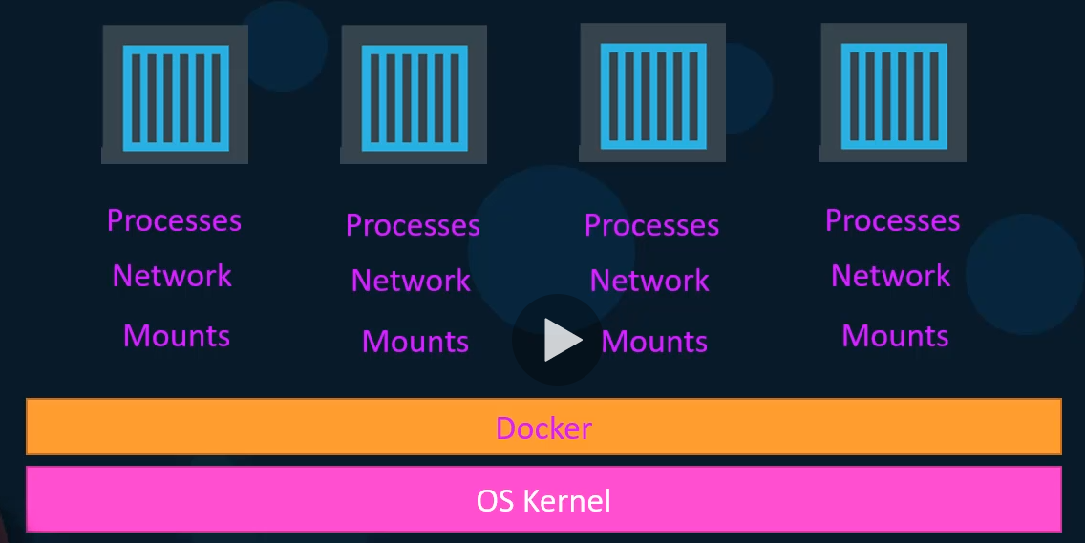**What are Containers**?

Containers are completely isolated environments that they can have their own processes or services, network interfaces, mounts. Just like virtual machines except they all share same OS Kernel.

There are different types of container in the market like LXC, LXD, and LXCFS etc. **Docker uses LXC containers setting up these container environments**.

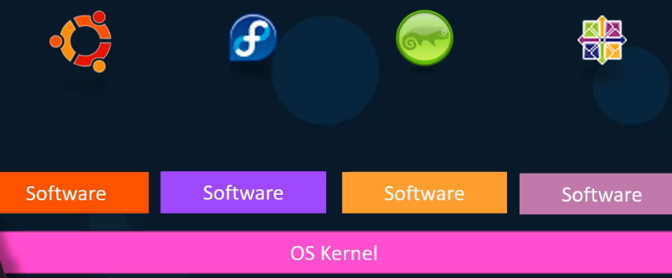Operating systems like Ubuntu, Fedora, Suse, Centos consists of OS kernel and set of software. OS kernel is responsible for interacting with underlying hardware. In this case, OS Kernel is Linux but software above it makes different operating system (User interface, compliers, file mangers etc.)

**Docker containers shares underlying kernel, what does it mean?**

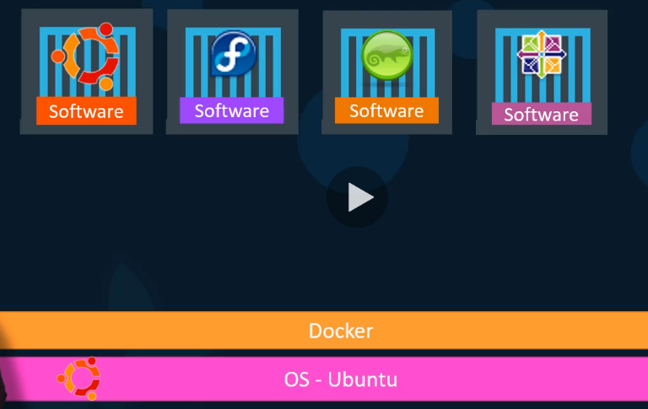Let us suppose we have Ubuntu OS with docker installed on it. Now docker can run any OS on top it as long as they are based on same kernel, in this case Linux. Here docker can run a container based on another distribution like debian, Fedora, Suse, and Centos.

**Docker uses the underlying kernel of the docker host which works with all OS’s above**

Windows is the OS that does not share same kernel as above OS’s. Therefore, you will not be able to run windows based container on a docker host with Linux on it. For that, it requires a docker on a windows server.

**Installing a Docker on windows and run, a container based on Linux is possible** because when you run a linux container on windows, we are not really running a linux container on windows, **windows runs a linux container on a linux virtual machine under the hoods.**

**Q. Is it disadvantage not being able to run another kernel on the OS?**

**A.** unlike hypervisor, docker is not meant to virtualize and run different operating systems and kernels on the same hardware. **The main purpose of docker is package, containerize applications, ship them and run** them anywhere any times.

**Virtual machines vs Containers:**

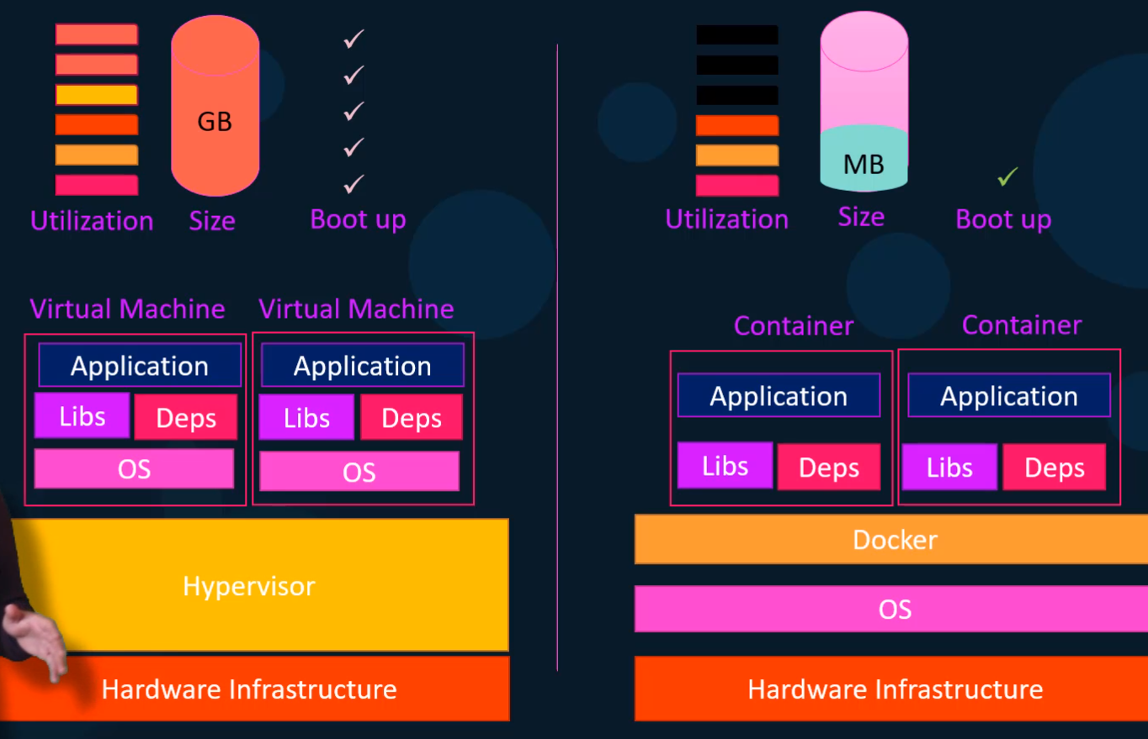

1. VM is heavy in space (GB’s) whereas docker containers are in MB’s. This allows Docker containers to boot up quickly in seconds, whereas VM takes minutes to boot up (entire OS).
2. Docker has less isolation as more resources (kernel) are shared between containers. Whereas VM’s has complete isolation from each other, since VM’s do not rely on underlying OS or Kernel. Here you can run different types on applications built on different OS’s such as Linux or Windows based apps on same hypervisor.

**In Real time, it is usually Containers and Virtual Machines**:

In large environments with thousands of application containers running on thousands of docker hosts, you will often see **containers provisioned on virtual docker hosts**.

Here we utilize the advantages of both technologies. We use **benefits of virtualization** (to easily provision or decommission docker hosts as required), at the same time make use of **benefits of docker** (to easily provision applications, and quickly scale them as required).

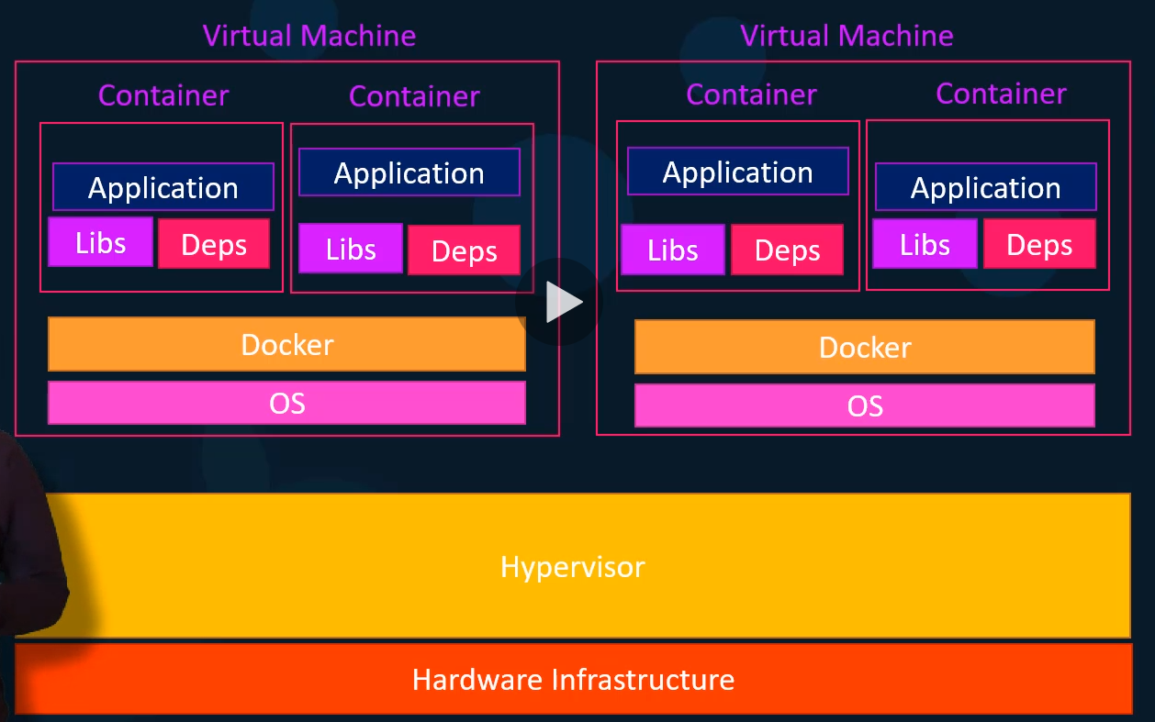

Before we provisioned one virtual machine for one application, but in this case, we provision one virtual machine for thousands of containers.

**How is it done?**

1. There are many containerized versions of applications readily available as of today.
2. Most organizations have their products containerized and available in a public docker Repo called **Docker hub or Docker store**.
3. Here you can find images of most common operating systems, databases, services and tools.
4. Just install docker and run the image to bring up the application.
5. If you want to run many instances of single application, just run as many as you want and configure a load balancer. If any instance fails, just destroy it and launch new one.

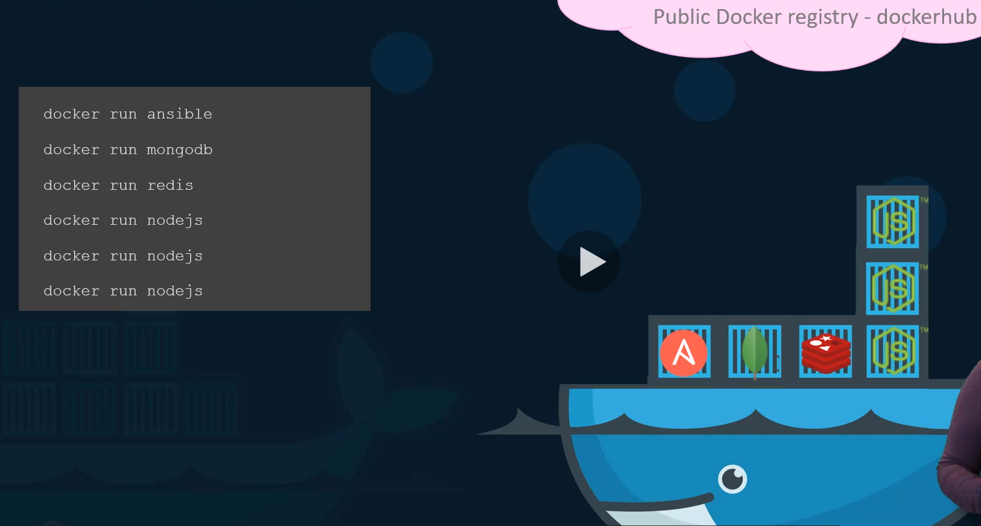

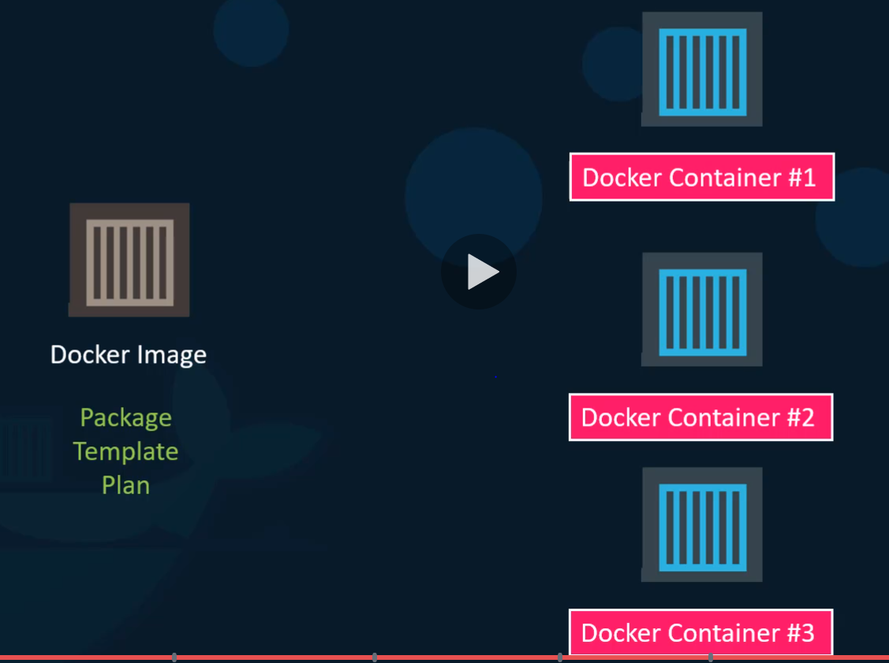

**Container Vs Image**:

1. **Image is a package or a template just like VM template. It is used to create one or more containers**.
2. Containers are running instances of images that are isolated and have their own environments and set of processes.

**Docker Editions**:

1. Community is set of free docker products.
2. Enterprise edition (priced) is certified and supported container platform. It has add-ons like image management, image security and universal control plan (managing and orchestrating container run times).



**Docker Commands:**

1. To Run a container from an image

Ex: **docker run nginx**

This will run an instance of nginx application on docker host. If image is not available on local, it will pull it from docker hub and store it in local hub and reuse.

1. **docker ps** – list all running conatiners
2. **docker ps -a** : will list all containers (running as well as stopped/exited)
3. **docker stop <containerId/Names>**: will stop the container

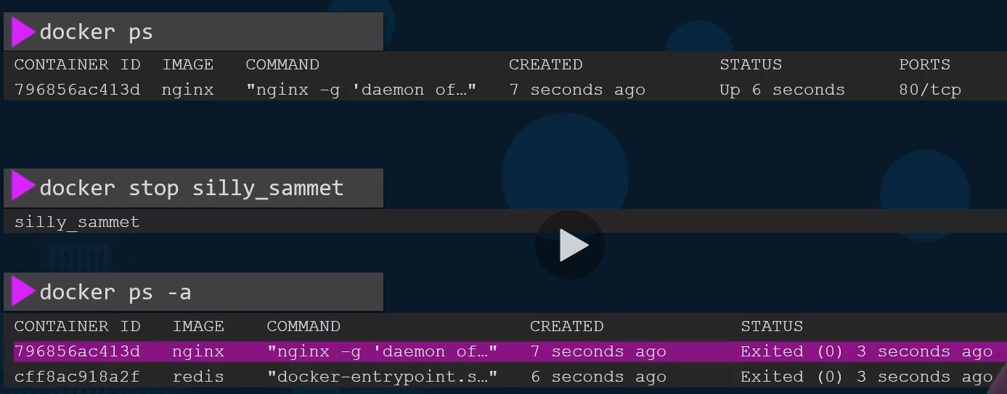

1. **docker rm <Name>**: To free memory and remove container

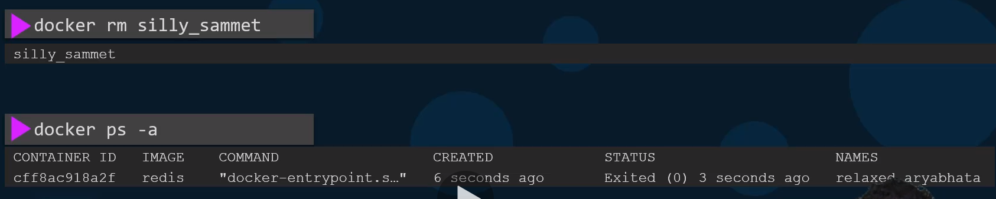

1. **docker images**: to see list of docker images on docker host

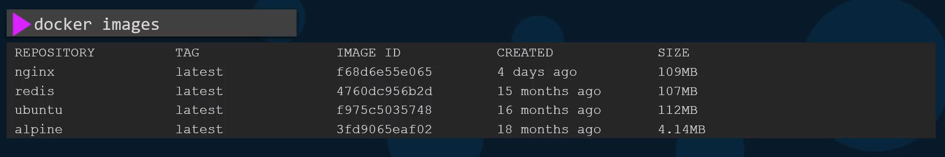

1. **docker rmi <ImageName>** : to remove image permanently from docker host. Delete all dependent containers to remove image.

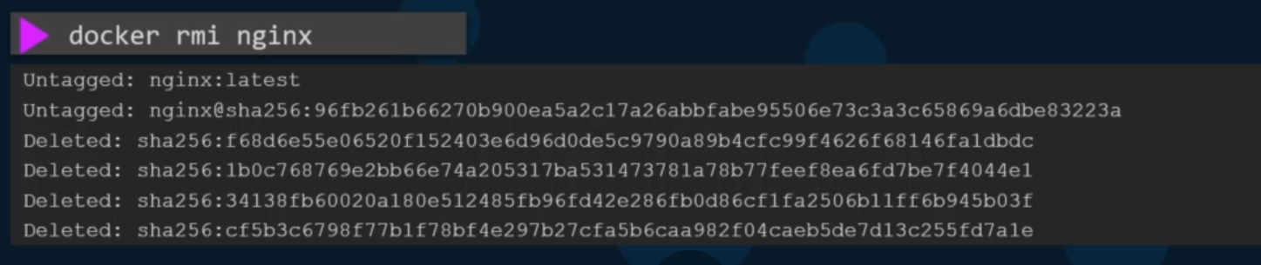

1. **docker pull** <ImageName> : to download the image from docker hub and keep it local.

**When you run Ubuntu image on docker host, it will run and exists immediately** because

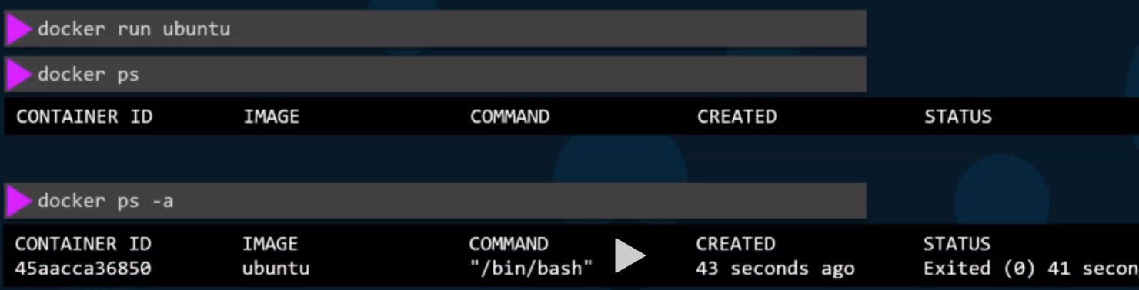

Unlike VM’s containers are not meant to run an operating system on it. Containers just meant to run a specific task or process such as to host an instance of web server or application server or database.

If no process or application running in the container, then container will exit.

**You can run a sleep process with docker command sleep to keep a container active**.

1. Executing a command when we run the container



1. **docker exec <containerName> <command>:** Executing a command on running container

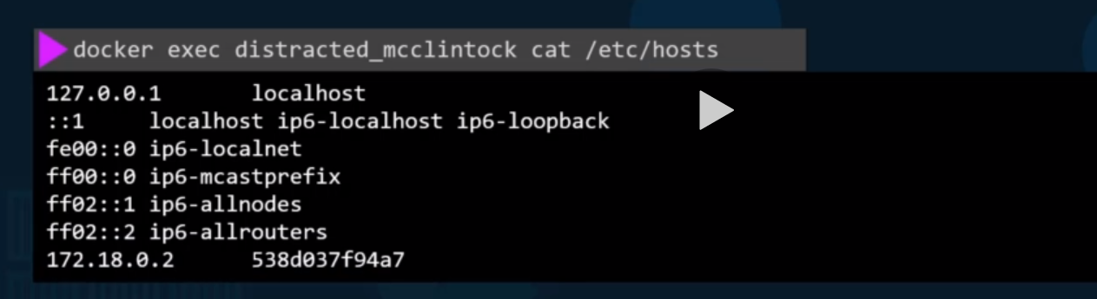

1. Run – attach and detach

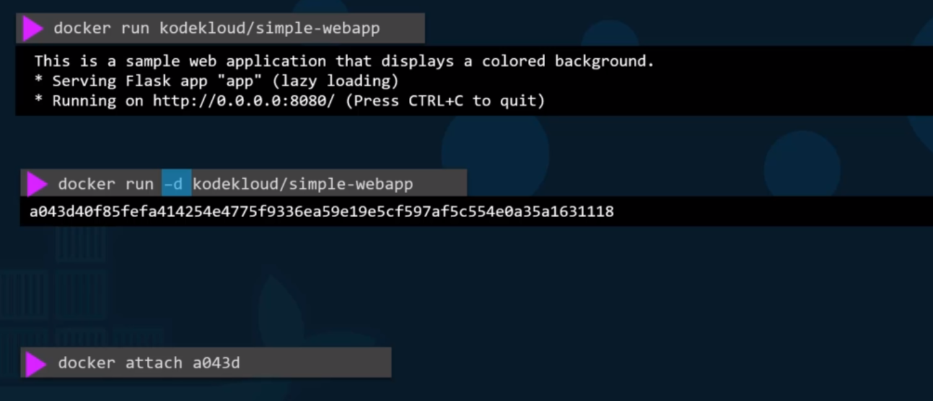

**Attach mode:** command output is attached to the console of docker container.

**Detach mode (-d):** This will run the container in background and console will be free to use for other commands. You can make it in attach mode by using **“attach**” command (first few chars of docker id is enough)

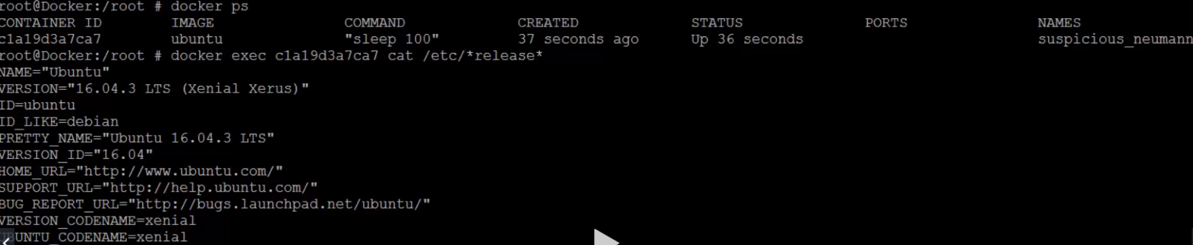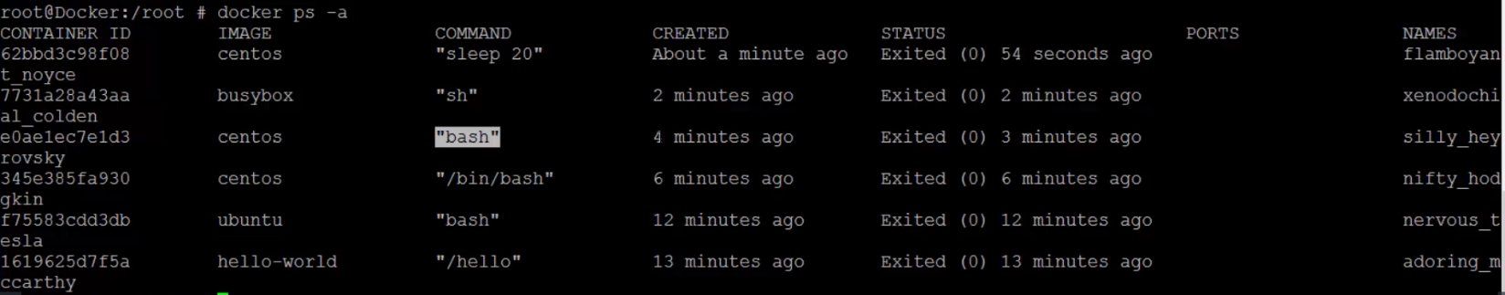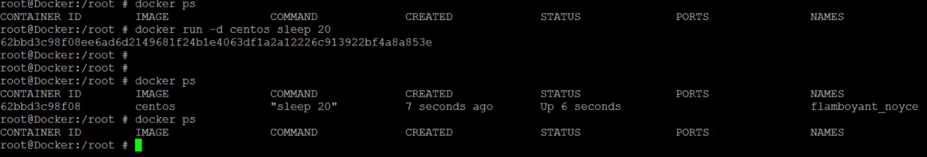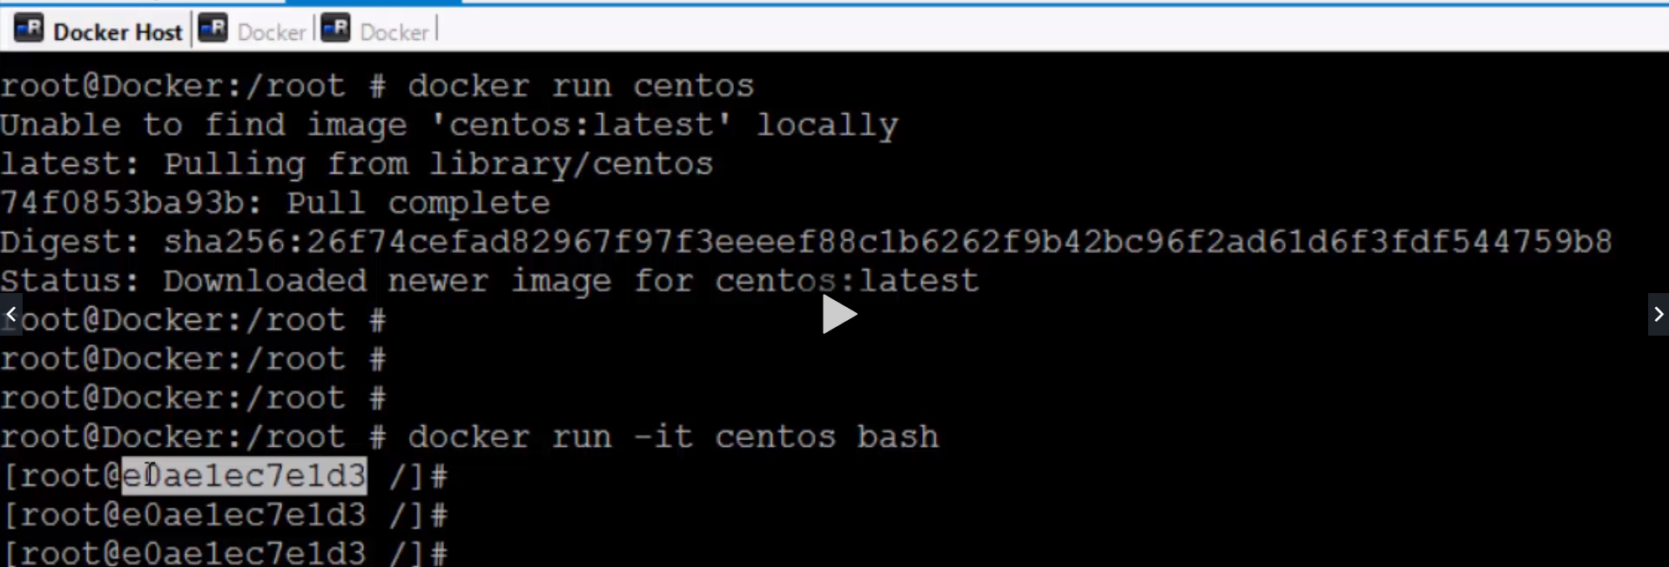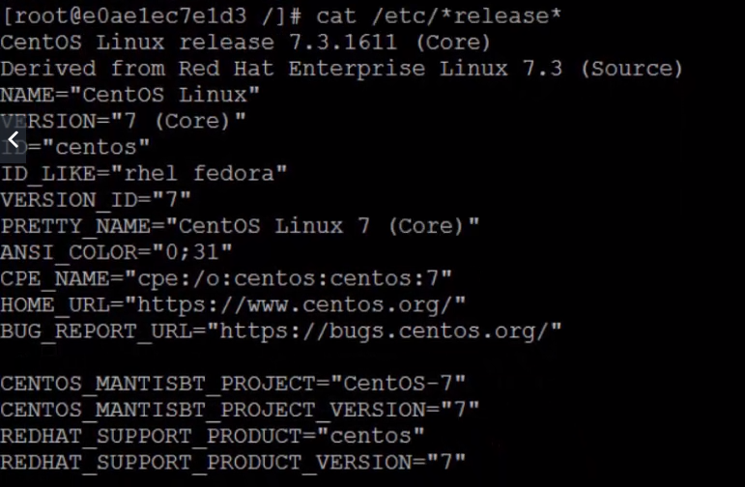

**Docker Run**:

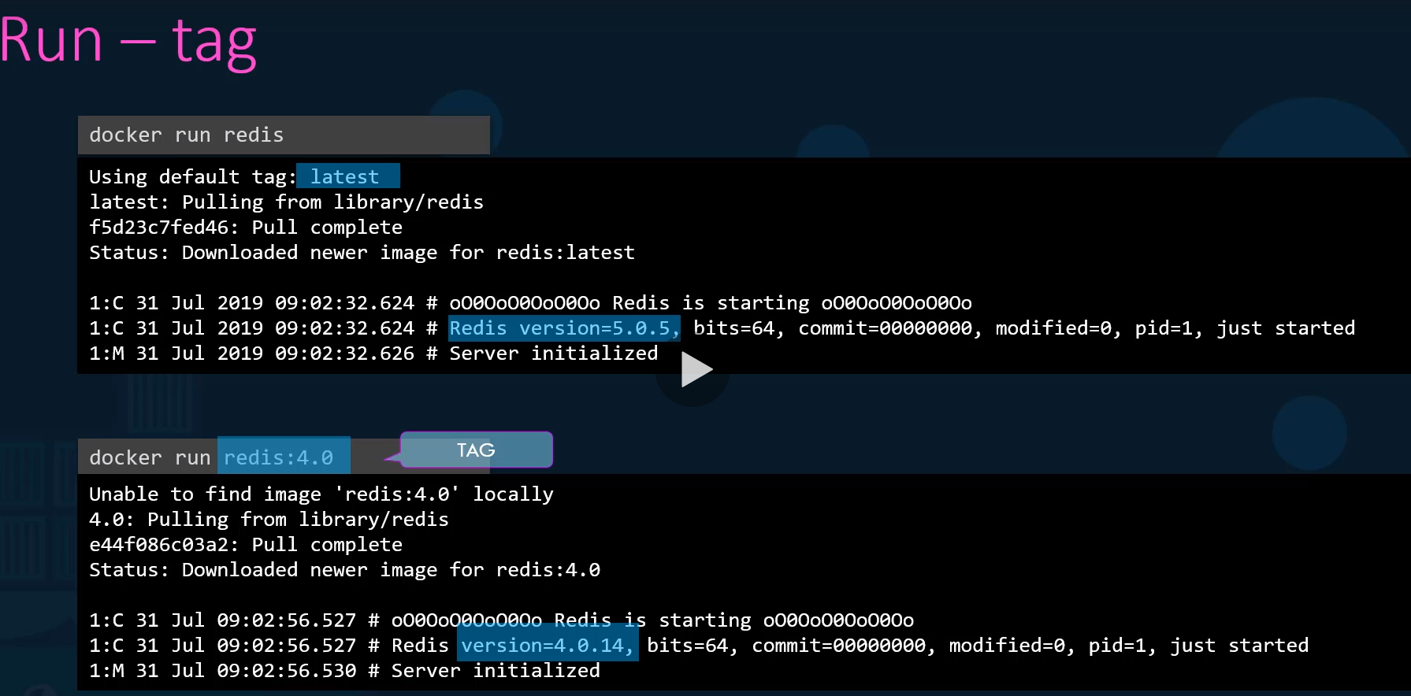

Docker hub will list all supported tags and links for all versions

**STDIN**: By default docker container will not listen to standard input. Even though you attached it to console, it is not able to read anything from console

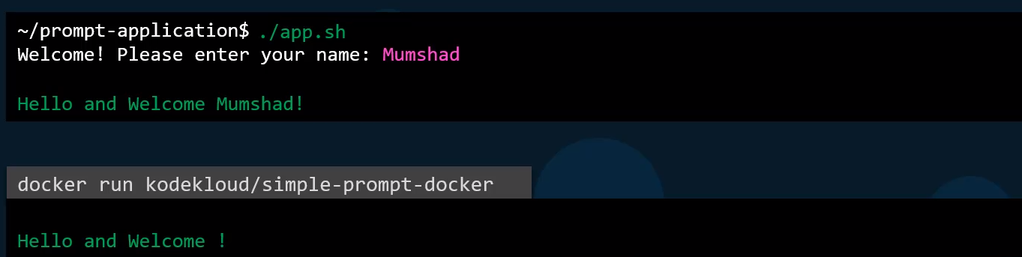

Below has interactive mode (-i) but missing prompt.

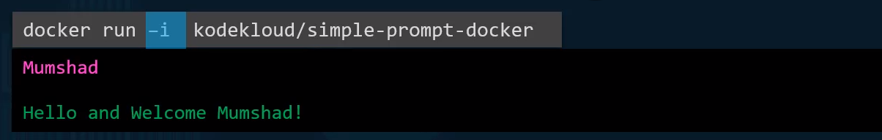

(-t): pseudo terminal: attaching to containers terminal

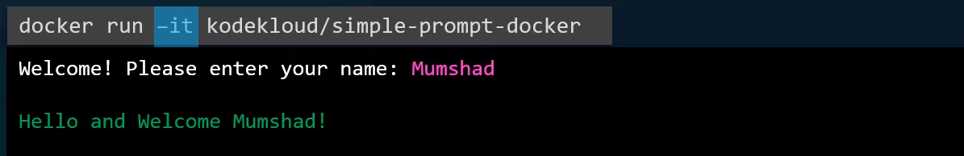

**PORT Mapping or PORT publishing**:

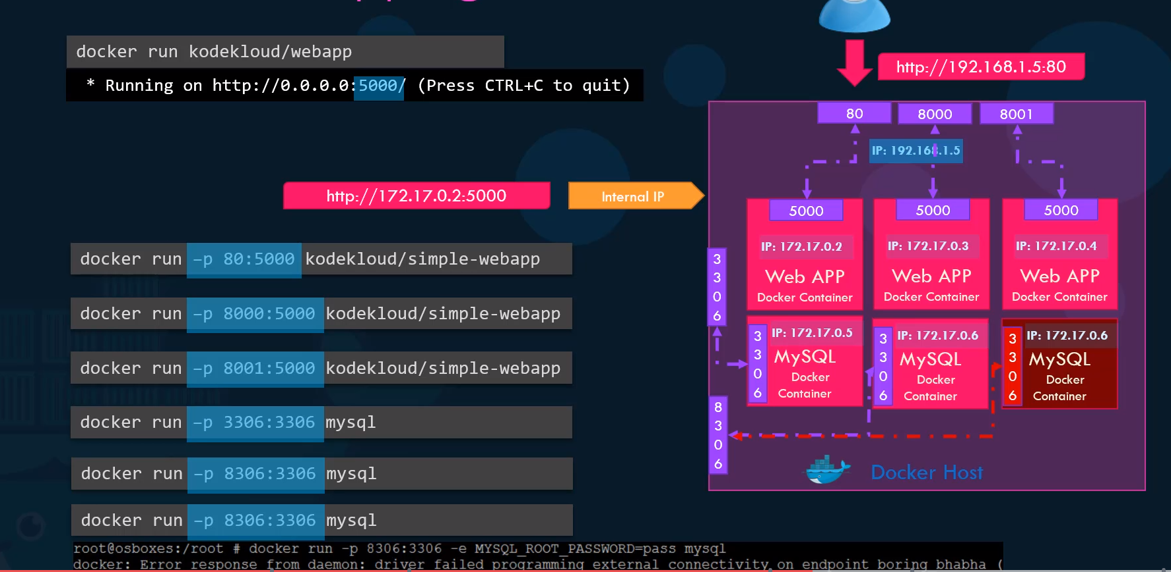

This internal IP address of container is accessible with in docker host (physical machine or VM on server). If you want to access web service from outside of docker host, then need to map the port to outside machine.

**Volume Mapping**: how data is persisted in docker container?

Docker container has its own isolated File system and changes made remains with container.

If we stop and remove container, then corresponding data files will be deleted from the system. In order to save data files, we do volume mapping to the directory outside of container.

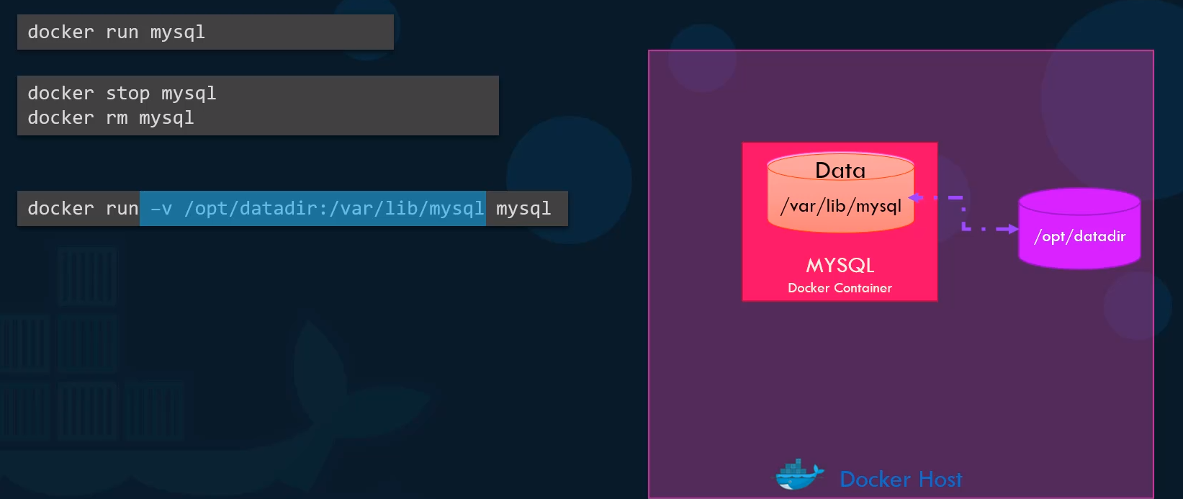

This will implicitly mount the external directory to the folder inside the container.

**Inspect Container**: use inspect to see additional details about the containers.

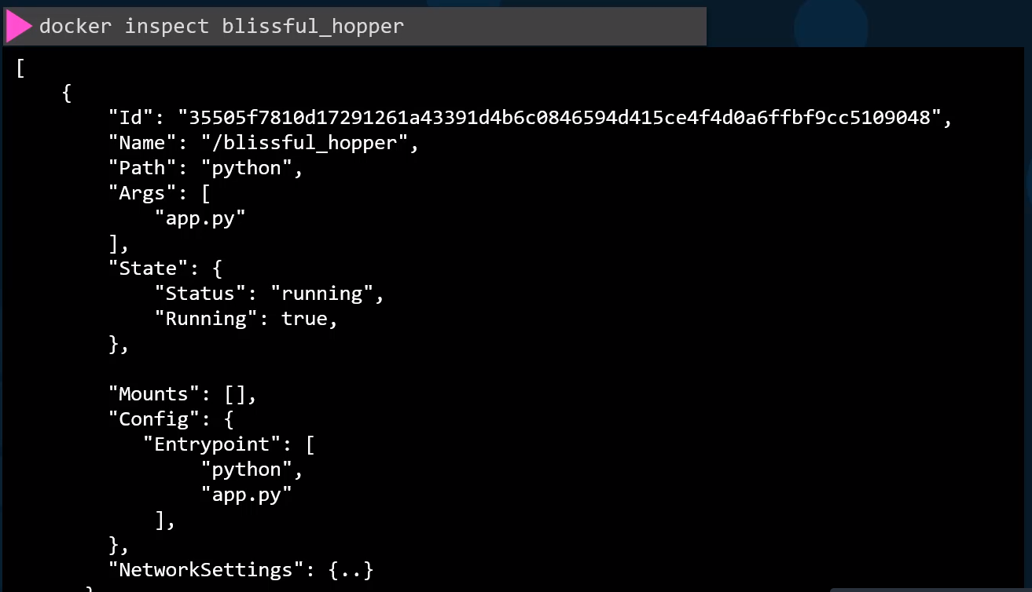

**Container Logs:** use this command to see logs when to ran a container in detach mode.

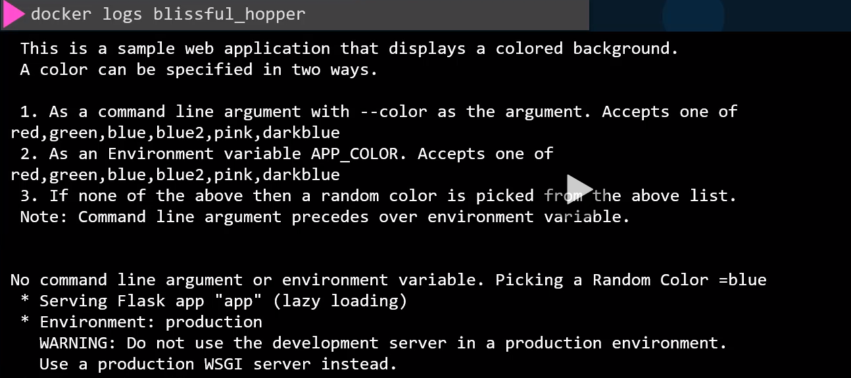

**Docker Images**:

**Containerizing**: dockerizing the application to for ease of shipping and deployment

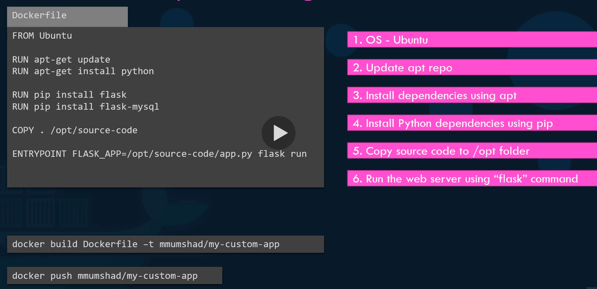

The FROM **instruction** initializes a new build stage and sets the Base Image for subsequent **instructions**. As such, a valid **Dockerfile** must start with a FROM **instruction**

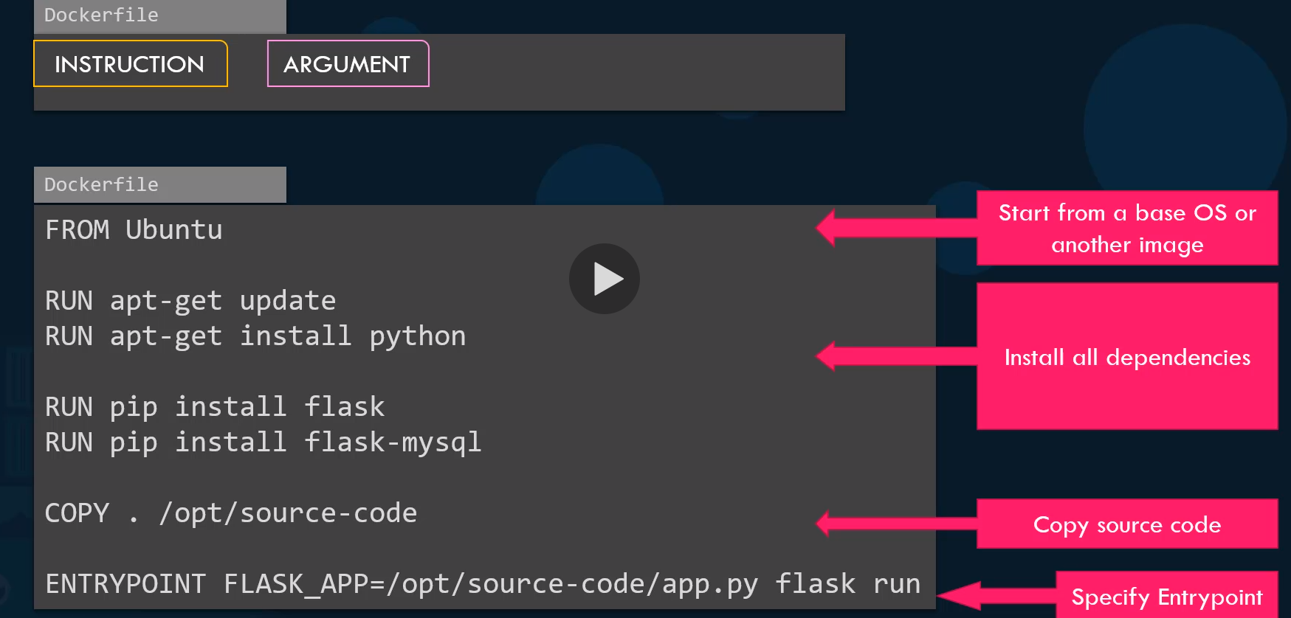

**ENTRYPOINT instruction** allows you to configure a **container** that will run as an executable.

More on **difference between CMD and ENTRYPOINT**: ... **CMD** sets default command and/or parameters, which can be overwritten from command line when **docker** container runs. **ENTRYPOINT** command and parameters will not be overwritten from command line. Instead, all command line arguments will be added after **ENTRYPOINT** parameters

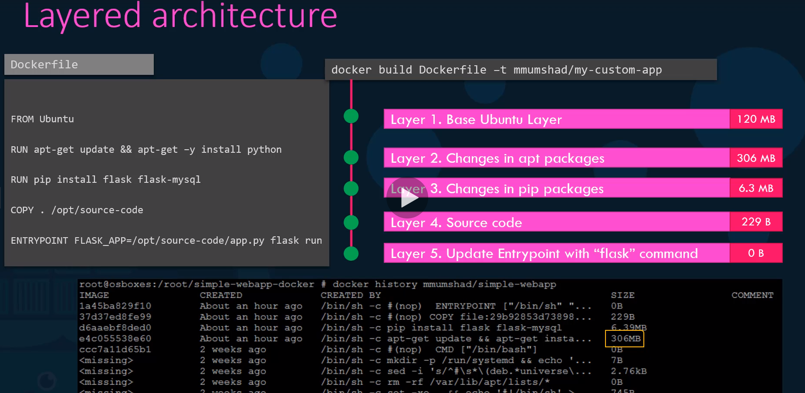

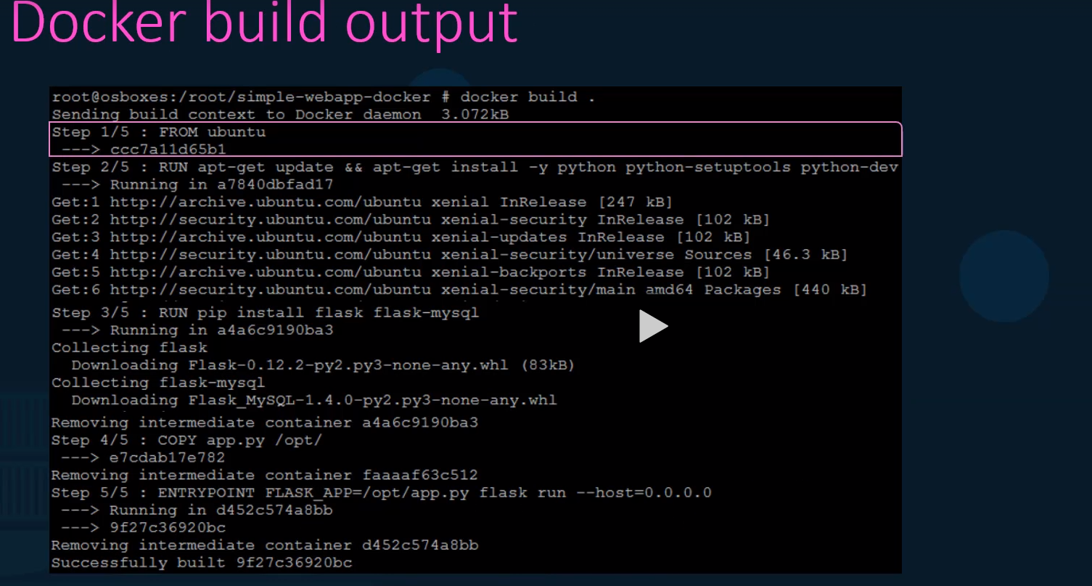

When you run a docker build command, you could see various steps involved and results of each task.

All the layers build are cached so the layered architecture helps to you restart docker build from that particular step in case it fails or if you want to ass new steps in the build process. (**No need to start over again**)

It has the intelligence to use the already ran steps from cache and start from the failed steps.

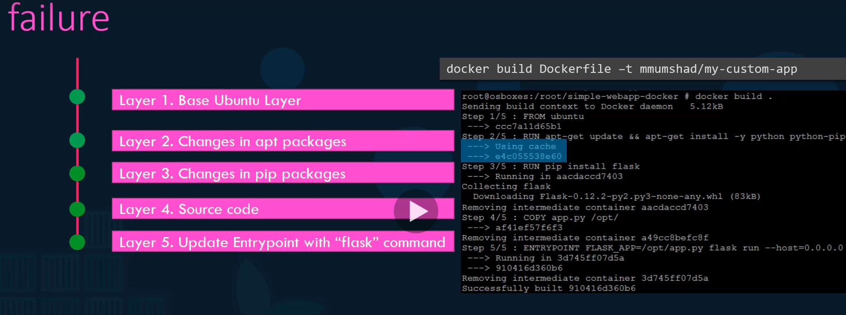

**Sample Demo for Image**:

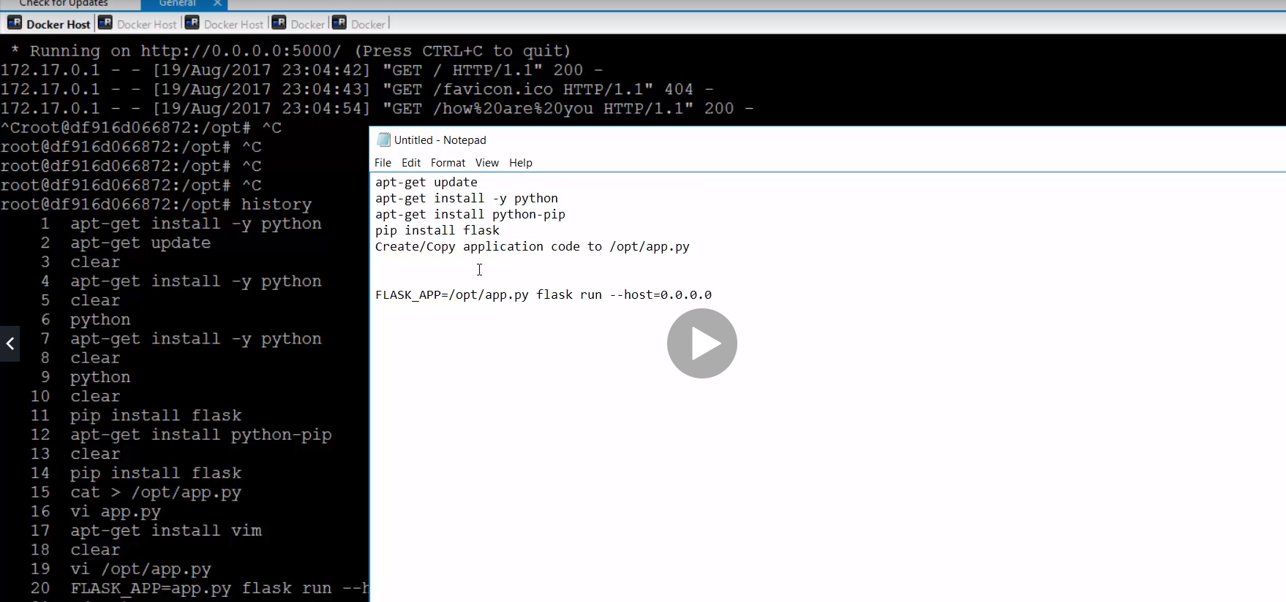

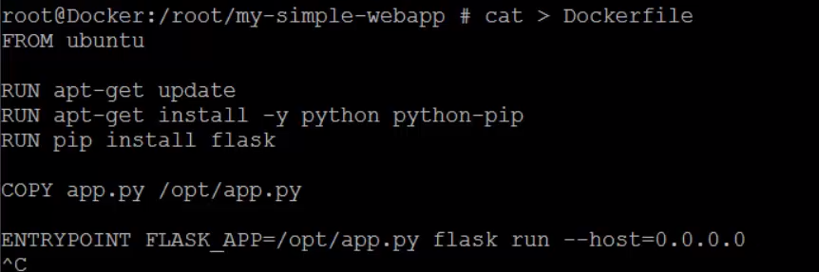

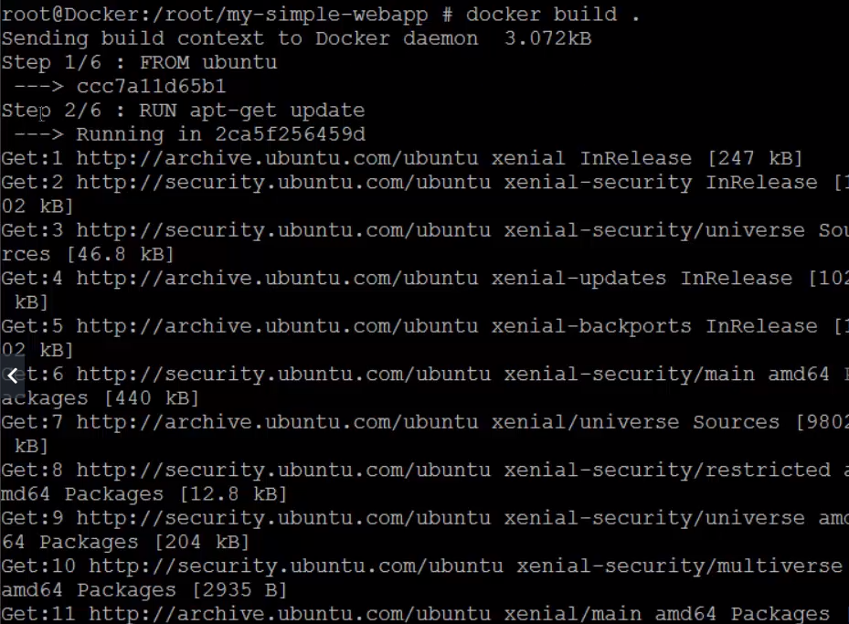

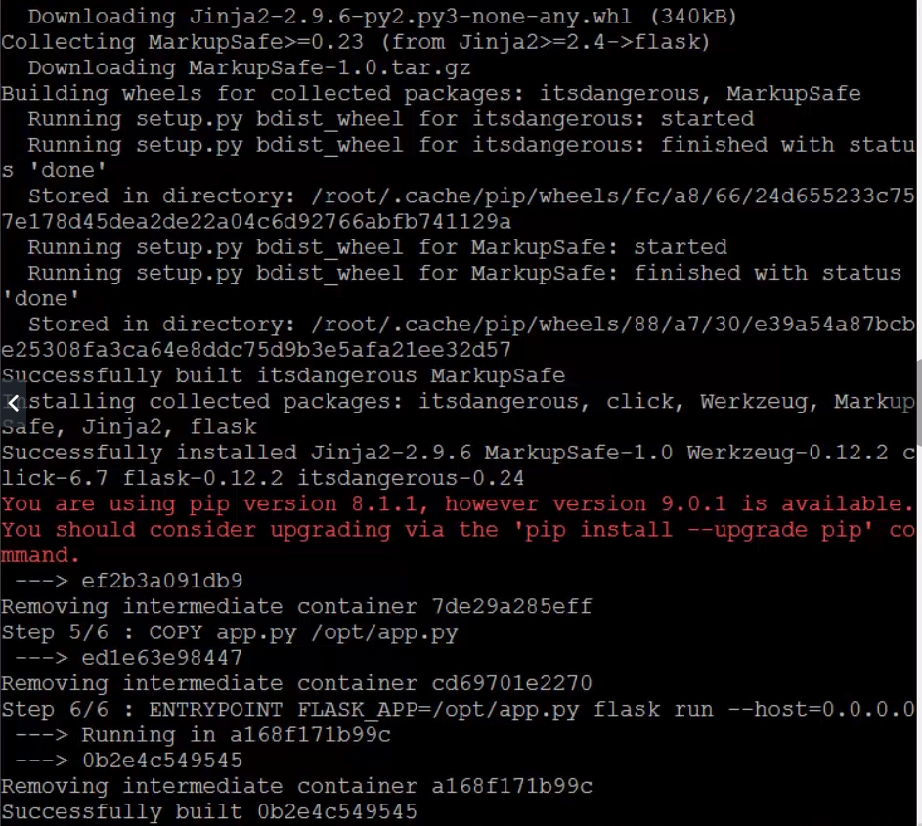

Using Cache and building again with “name”:

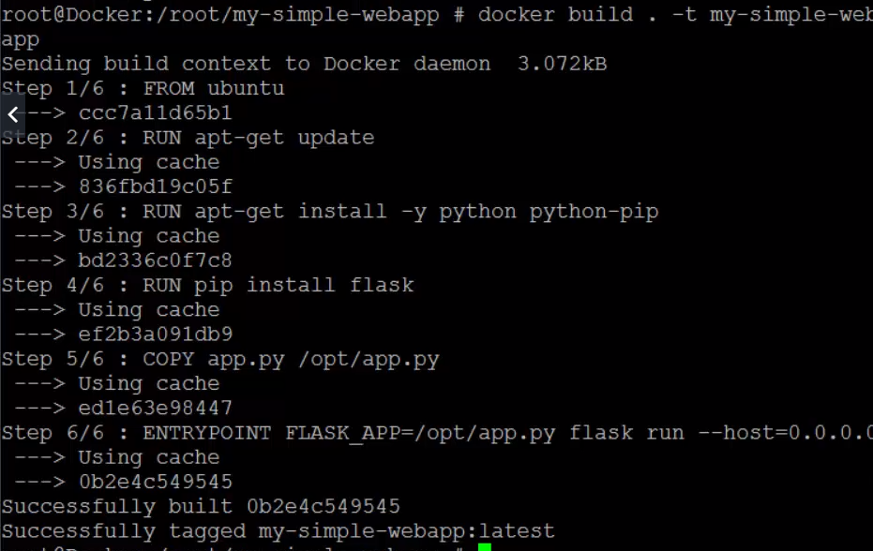

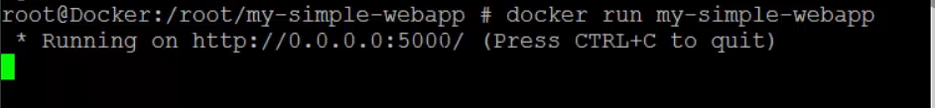

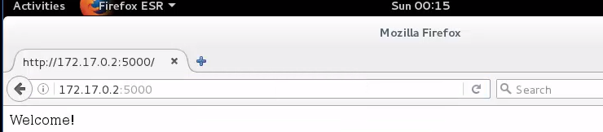

Pushing to dockerHub: fails if you try to push to main library

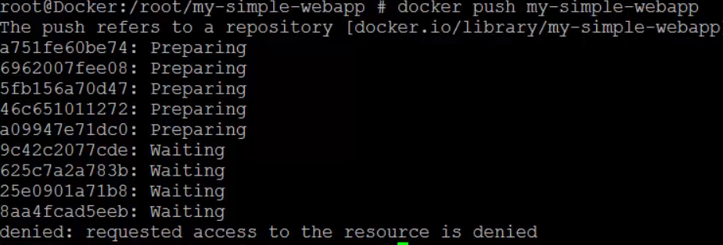

To push into docker hub, you need to specify organization name while building image

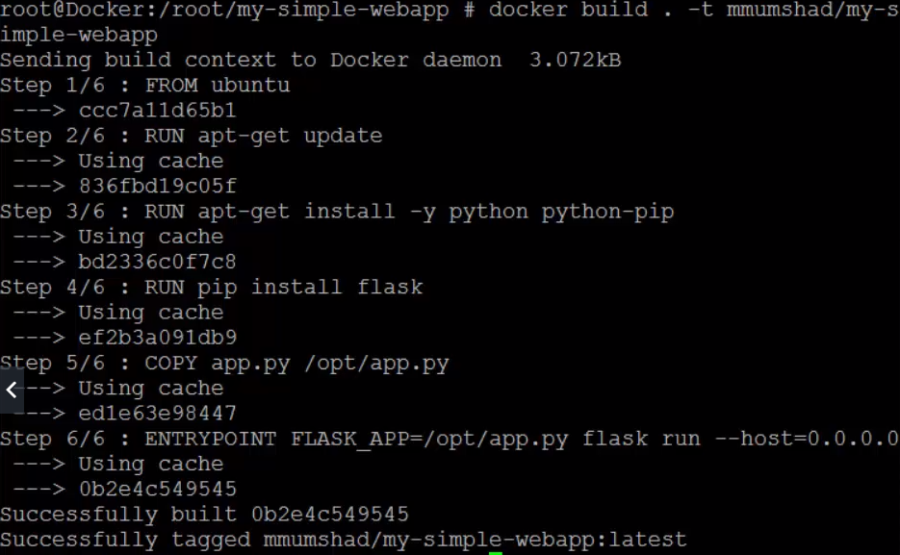

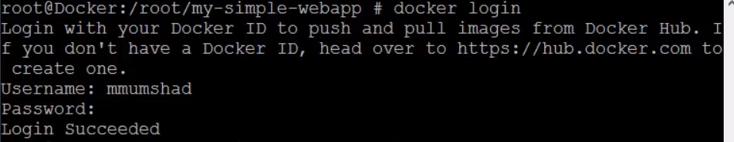

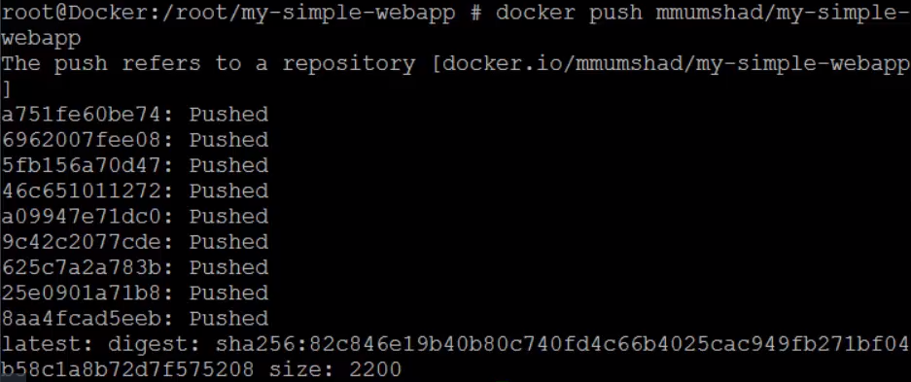

In docker hub



Environment variables:

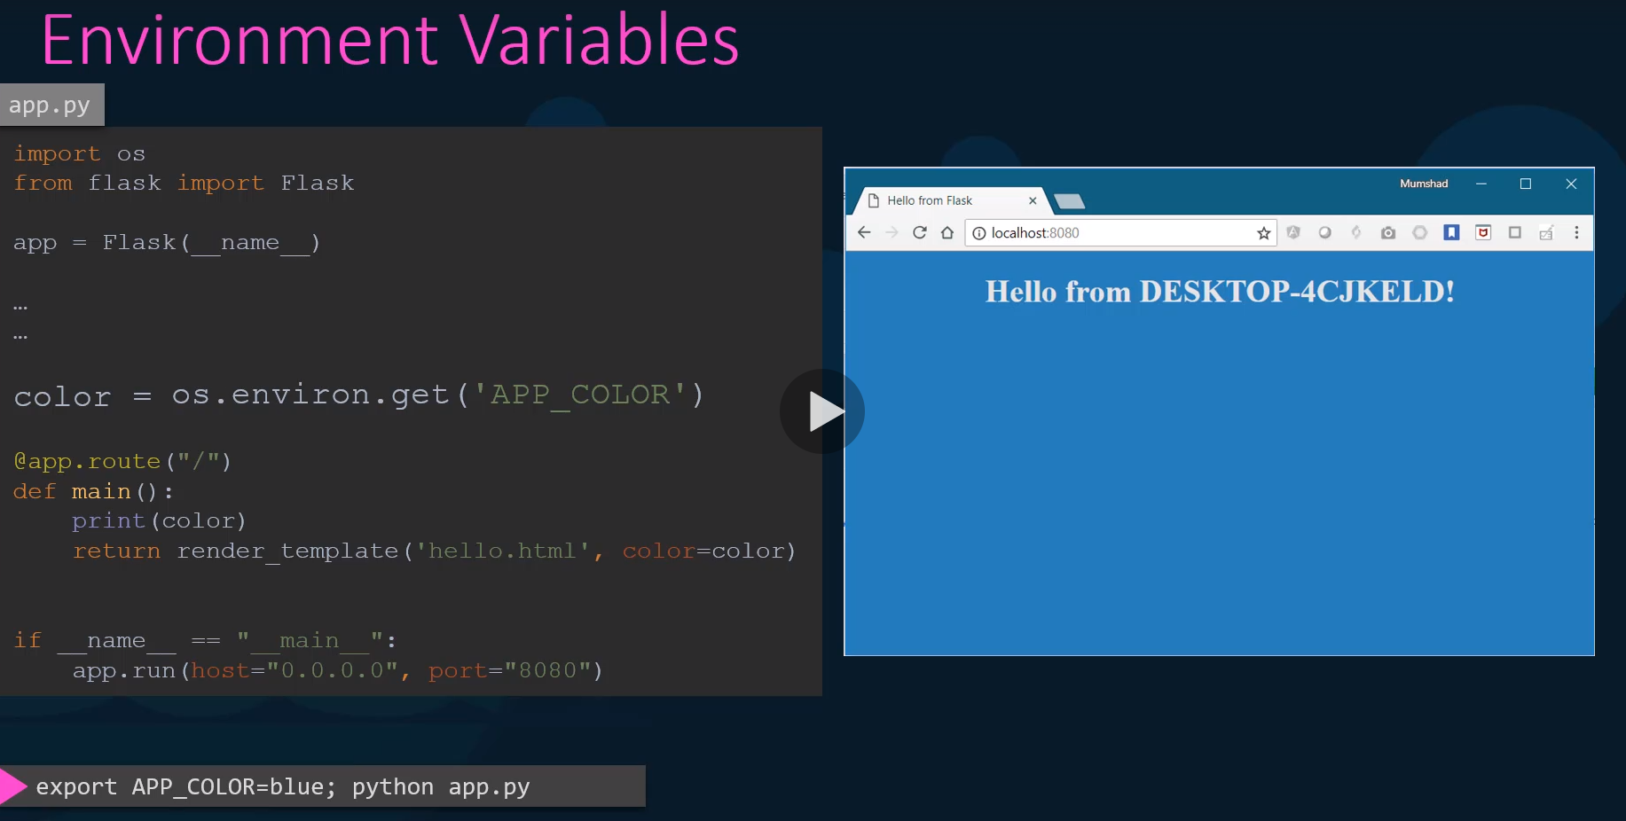

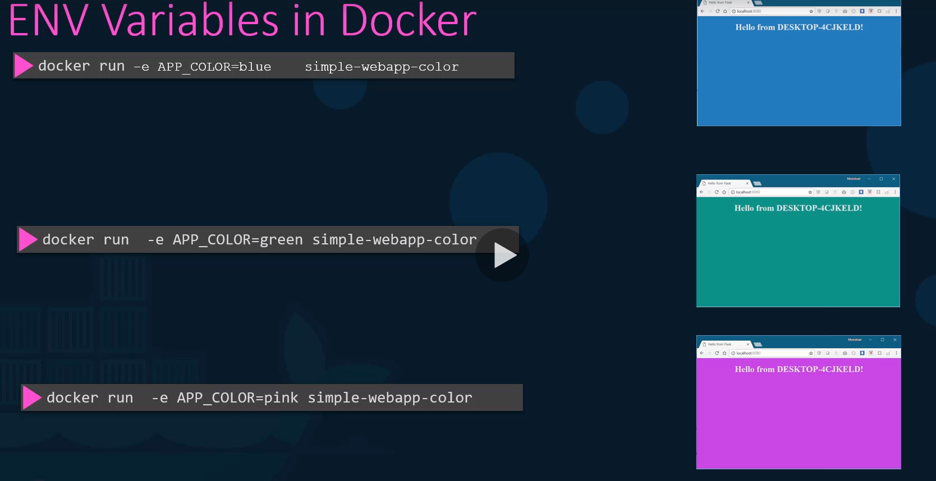

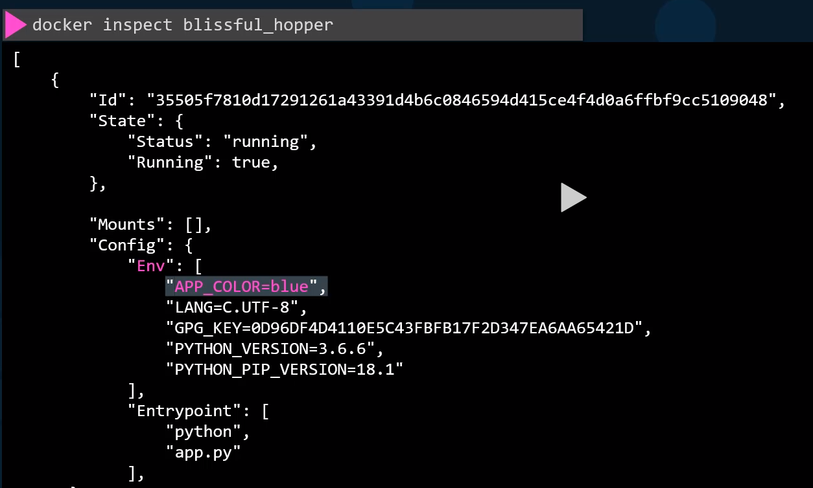

**COMMAND vs ENTRYPOINT**:

Every image will have to run some process to keep the container up and running, for that **CMD** will execute the command

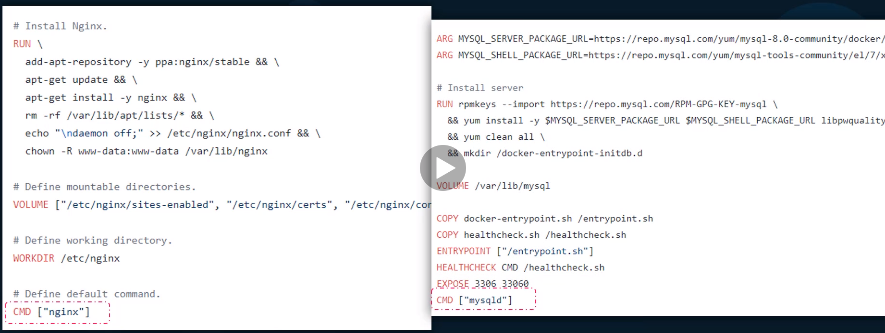

Ubuntu has “Bash” command to execute. So it searches for terminal, if not find it exists.

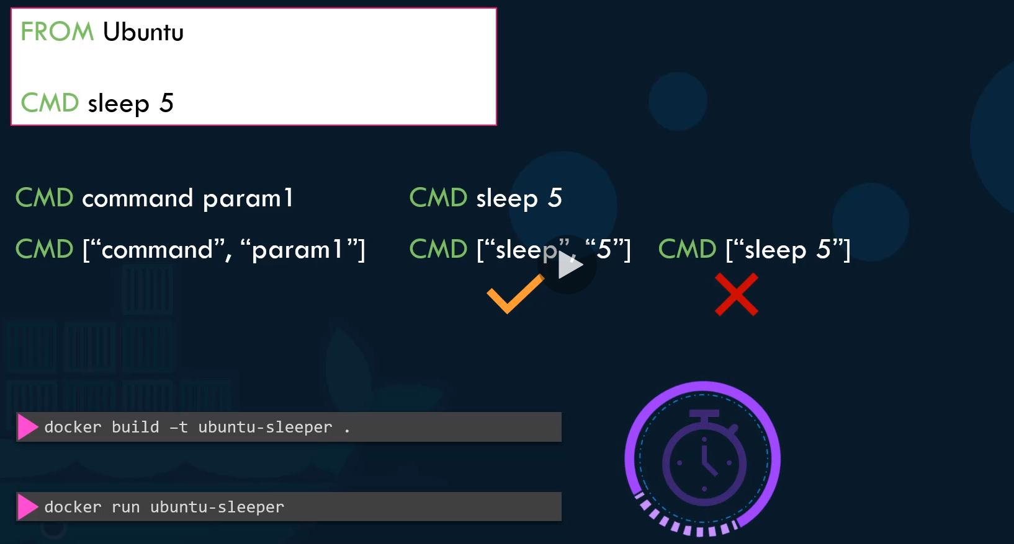

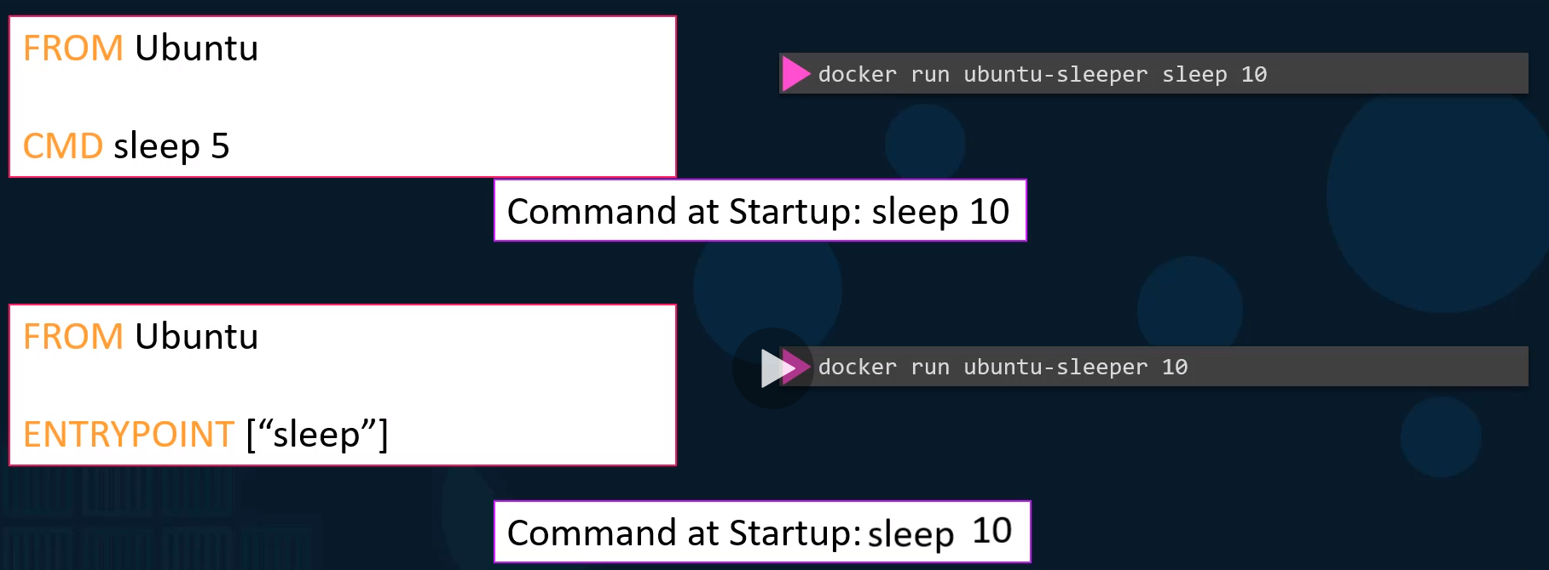

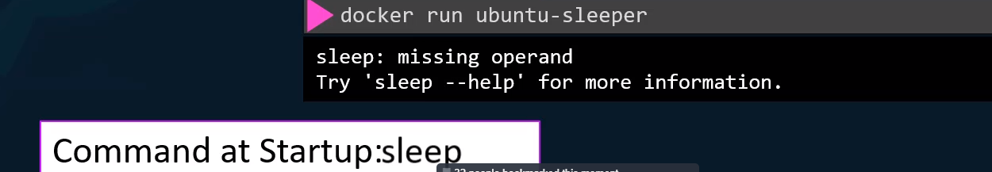

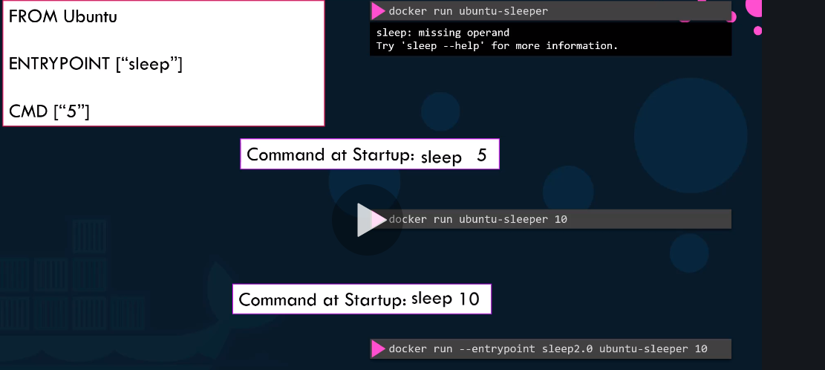



**Docker Compose:**

Compose is a tool for defining and running multi-container Docker applications. With Compose, you use a YAML file to configure your application's services. Then, with a single command, you create and start all the services from your configuration. Run Docker-compose up and Compose starts and runs your entire app.

A Docker file is a simple text file that contains the commands a user could call to assemble an image whereas Docker Compose is a tool for defining and running multi-container Docker applications. Docker compose uses the Docker file if one add the build command to your project's Docker-compose.yml.

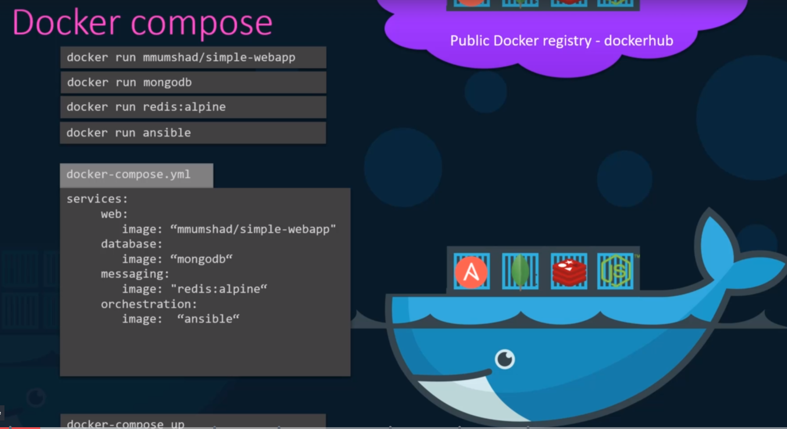

Demo using below application:

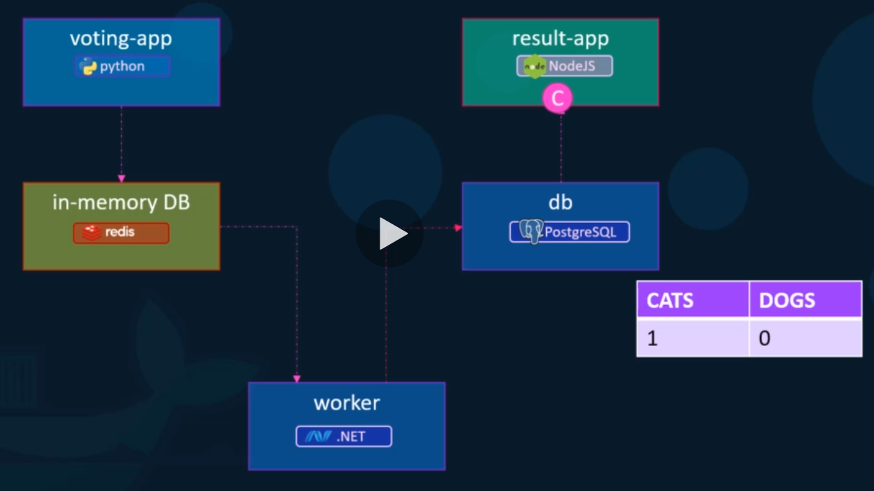

Without docker compose, and if you run containers individually

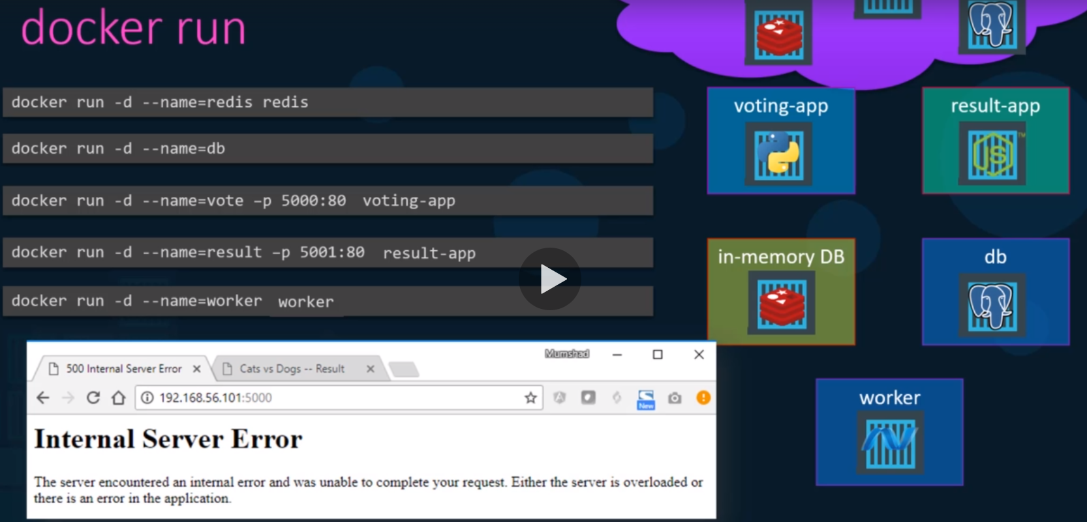

Error because of missing **links** between containers

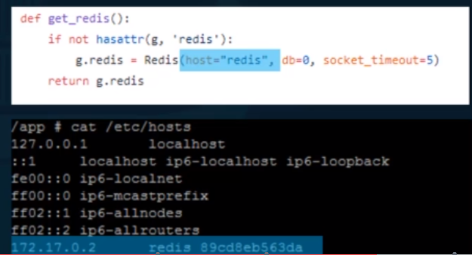When you specify -- link with docker run command, it will create an entry in /etc/hosts file with IP Address of linked container.

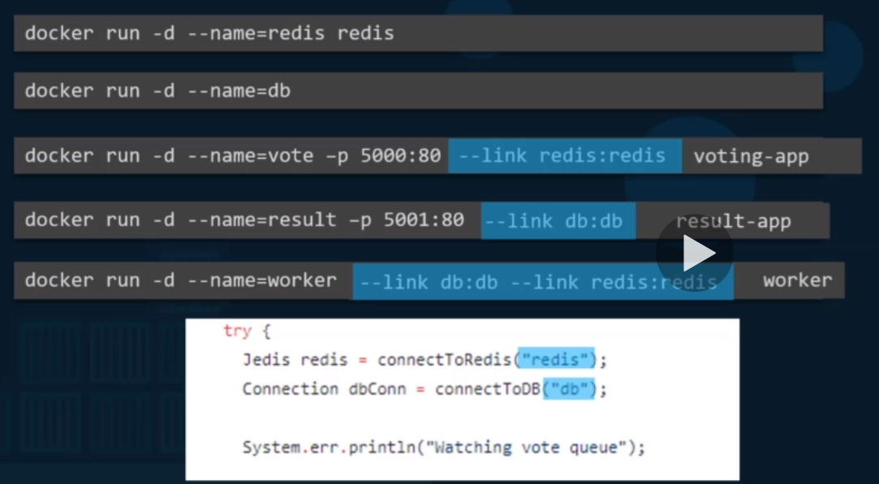

Docker compose the above application:

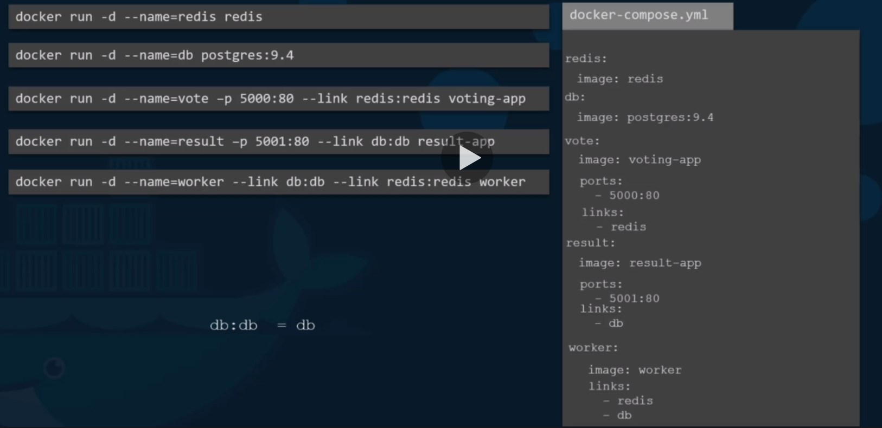

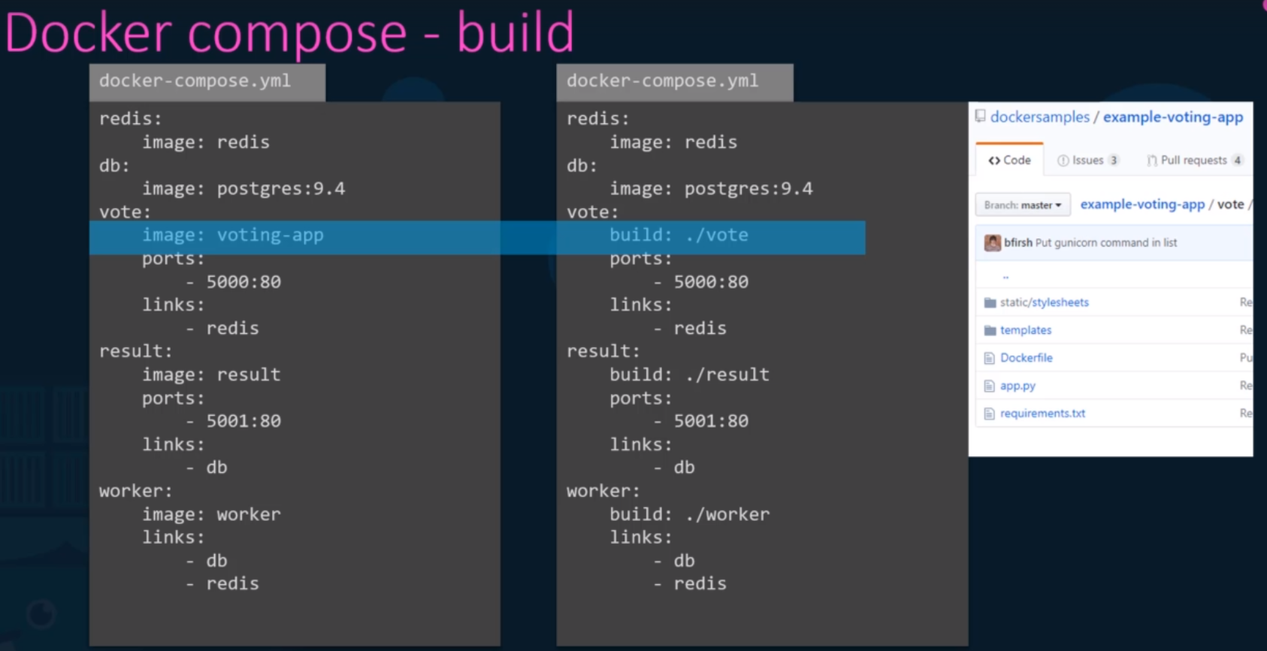

**Docker Compose Versions**:

Version 1: It has a limitation, if you want to deploy containers on a different network other than default bridge network, there is no way of specifying in compose file. In addition, dependency on container startup cannot be specified

Version 2:

1. It has parent level tag Services, Need to specify Version on the top.
2. By default, Docker will create a dedicated bridge network for the application and attaches all containers to that bridge network. Now all containers can communicate to each other using respective service names. (**No Links Required)**
3. can specify the dependency in between containers.

Version 3: Latest ( supports docker-swarm)

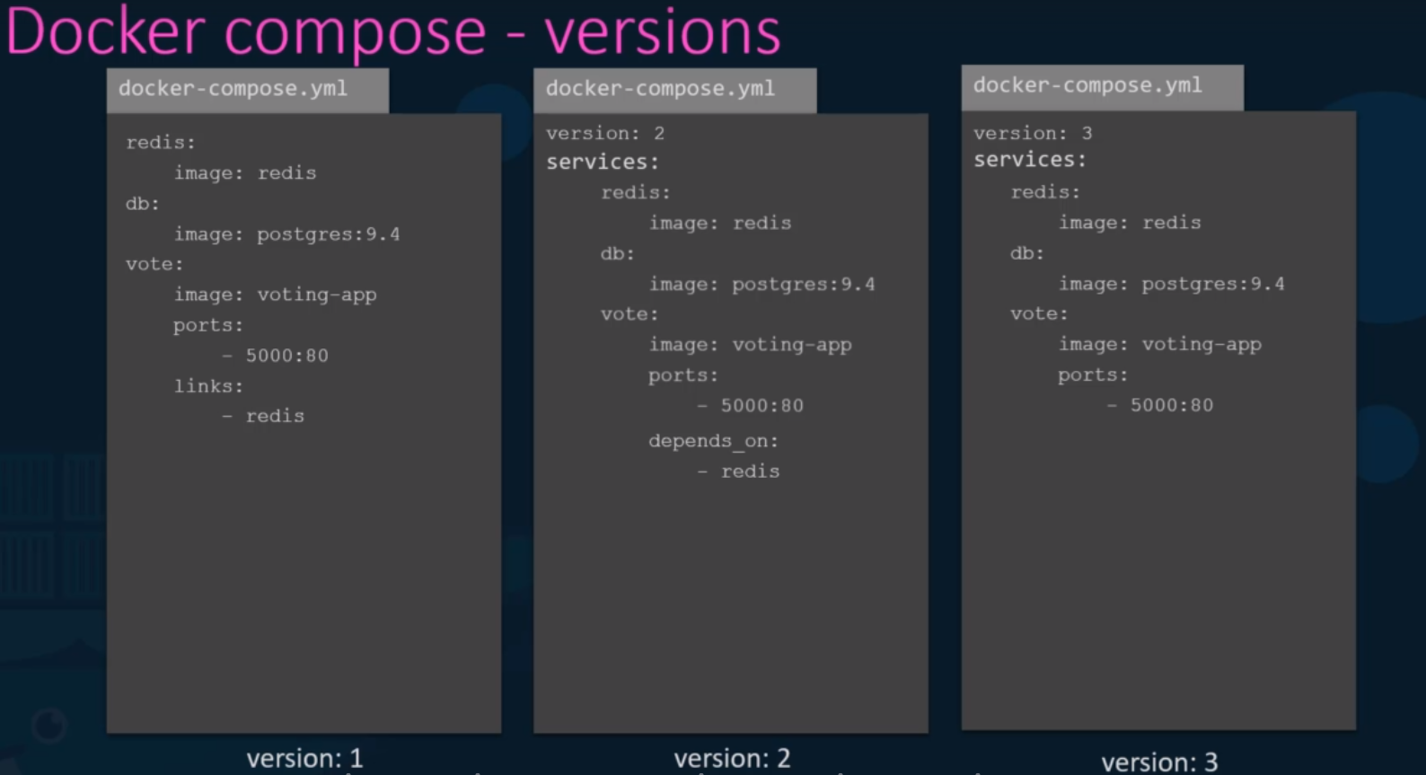

To create separate network to users and containers: create a tag “networks” in docker compose file and add networks under it.

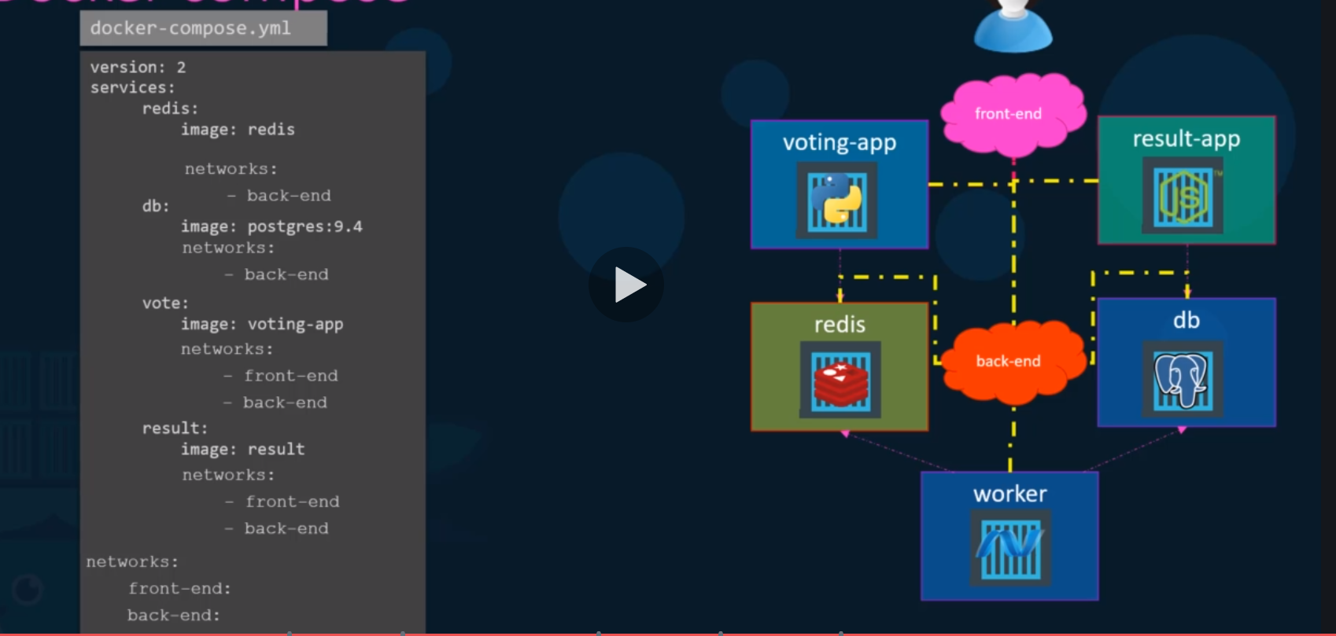

**Docker Registry:** central Repo for all Docker images.

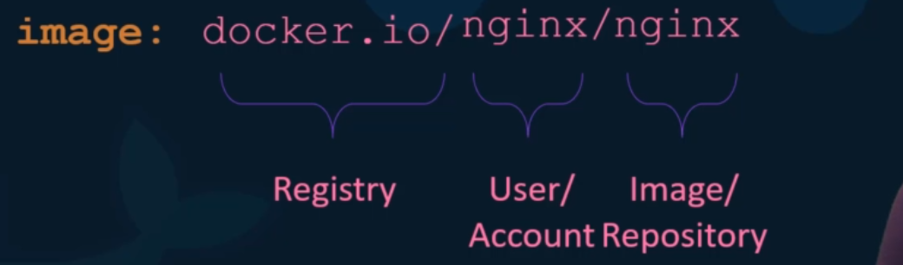

Docker image <registry><Acct>/<Image-Repo>. By default, it pulls docker image from docker.io

**Private Registry**:

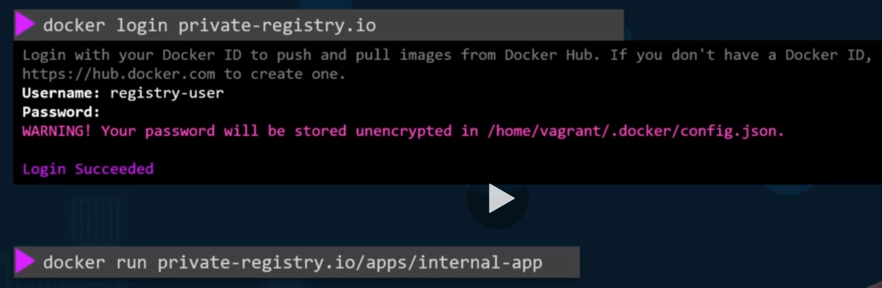

**Deploy Private Registry:**

Create custom registry on docker host

It is a application and name of the image is “registry” and it exposes API on port 5000

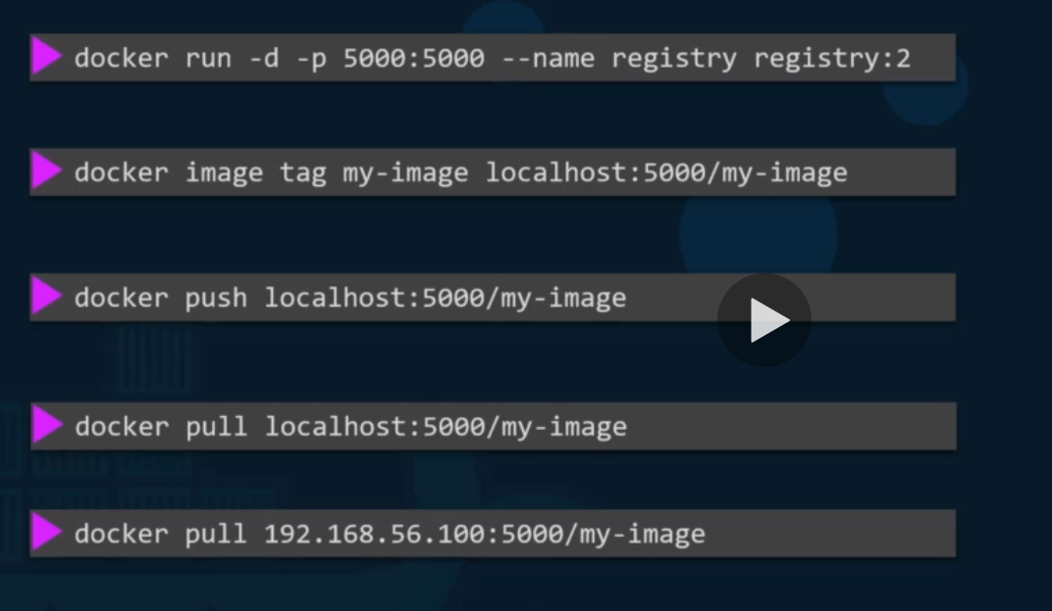

**Docker Engine:**

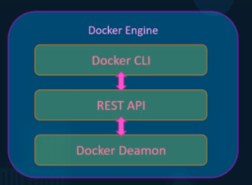Has three main parts

1. Docker CLI: Command line interface to run commands. It uses Rest API to interact with docker Daemon.
2. Rest API: Interface that programs use to talk to Daemon service. Can create own tools using this API.
3. Docker Daemon: It is a background process that manages docker objects (Images, Volumes, Networks)

Docker CLI can be on different host and can be still on the remote host using “-H” in the command.

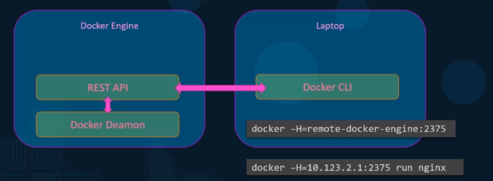

**Containerization**:

Docker uses Namespace to isolate workspace process id, Network, Mount etc. and are created in their own namespace.

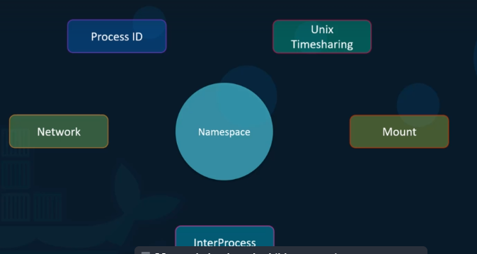

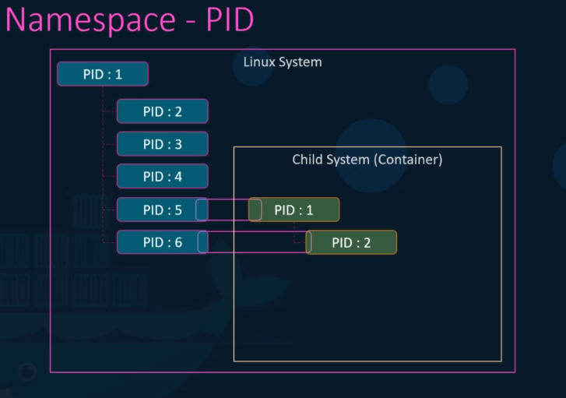

Can share/restrict resources using below commands.

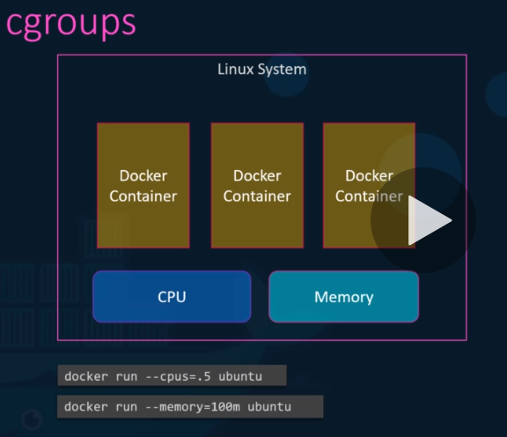

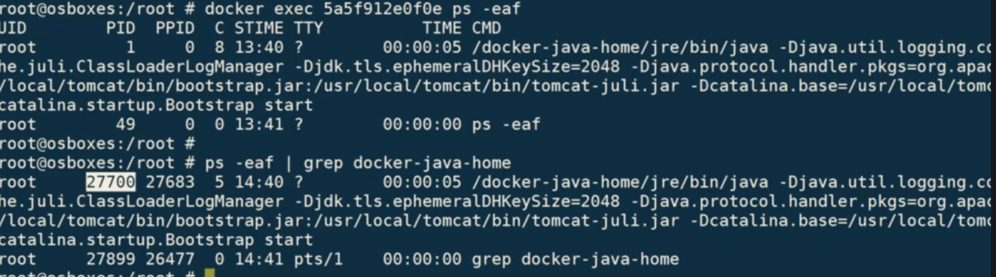

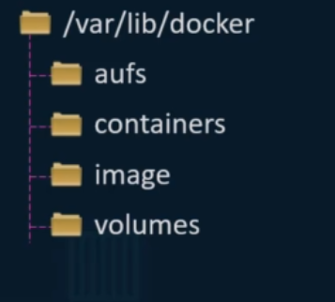**Docker Storage:**

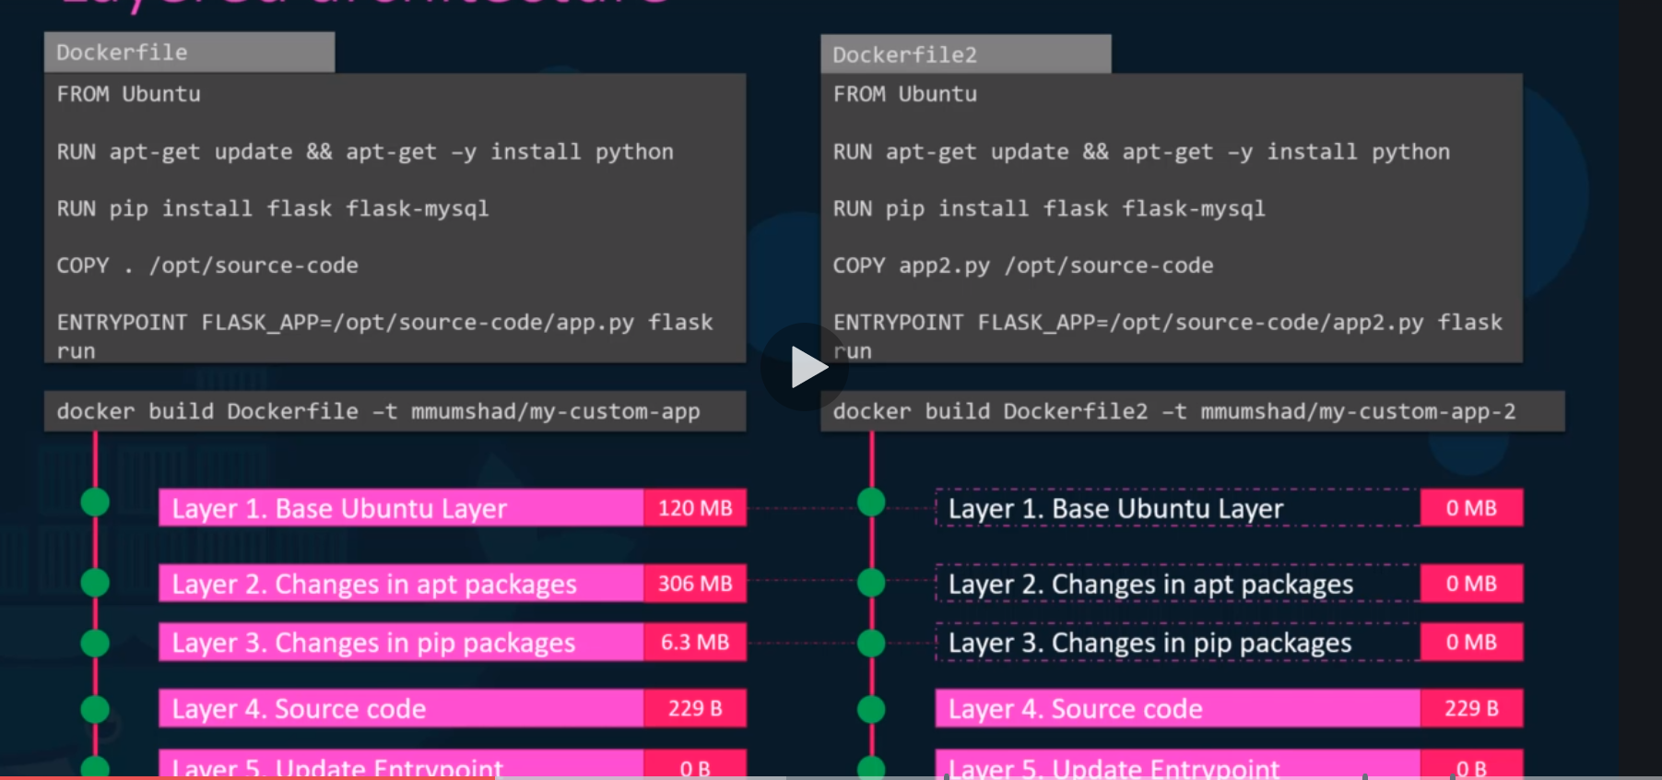

Docker reuses the layers from previous images cache.

All these 5 layers are read only, layer 6 container is read-write which stores data of container operations like logs. This data is available until container is alive.

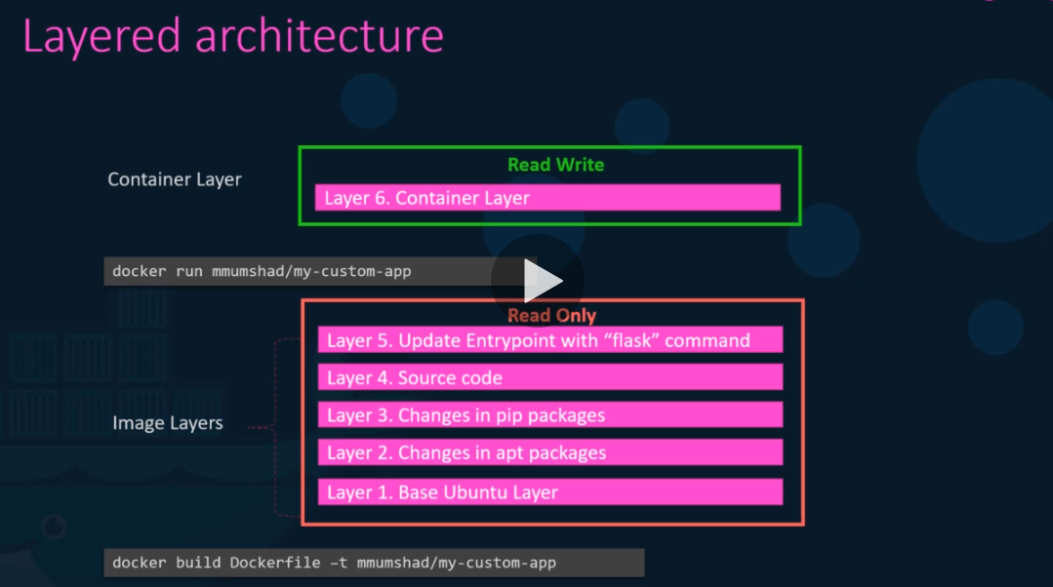

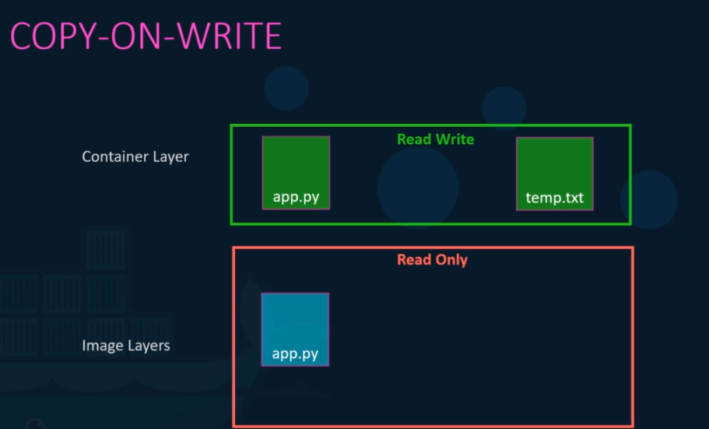

Image layer is read only. when we try to modify files in image layer, docker automatically creates writable file in container layer and uses it.

**Volumes**: To create persistent volume to container, which stays available even after container is exited and removed.

1. Volume mounting: if you mount to volumes directory inside docker lib.
2. Bind mounting: if you mount to separate location than docker lib.

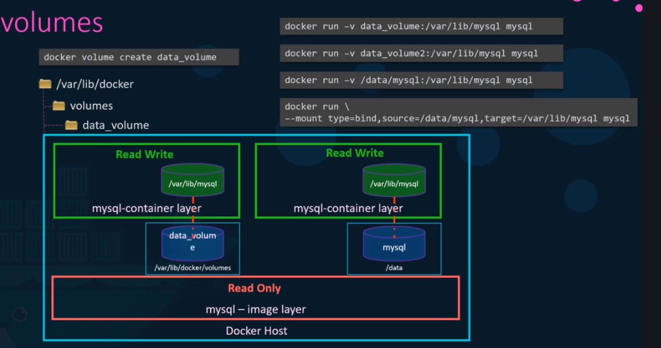

Docker uses Storage drivers to maintain layered architecture. 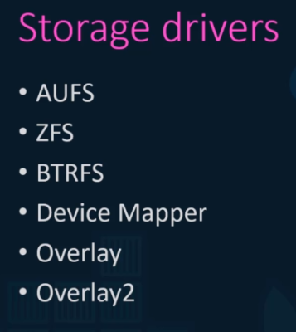

docker info | more  
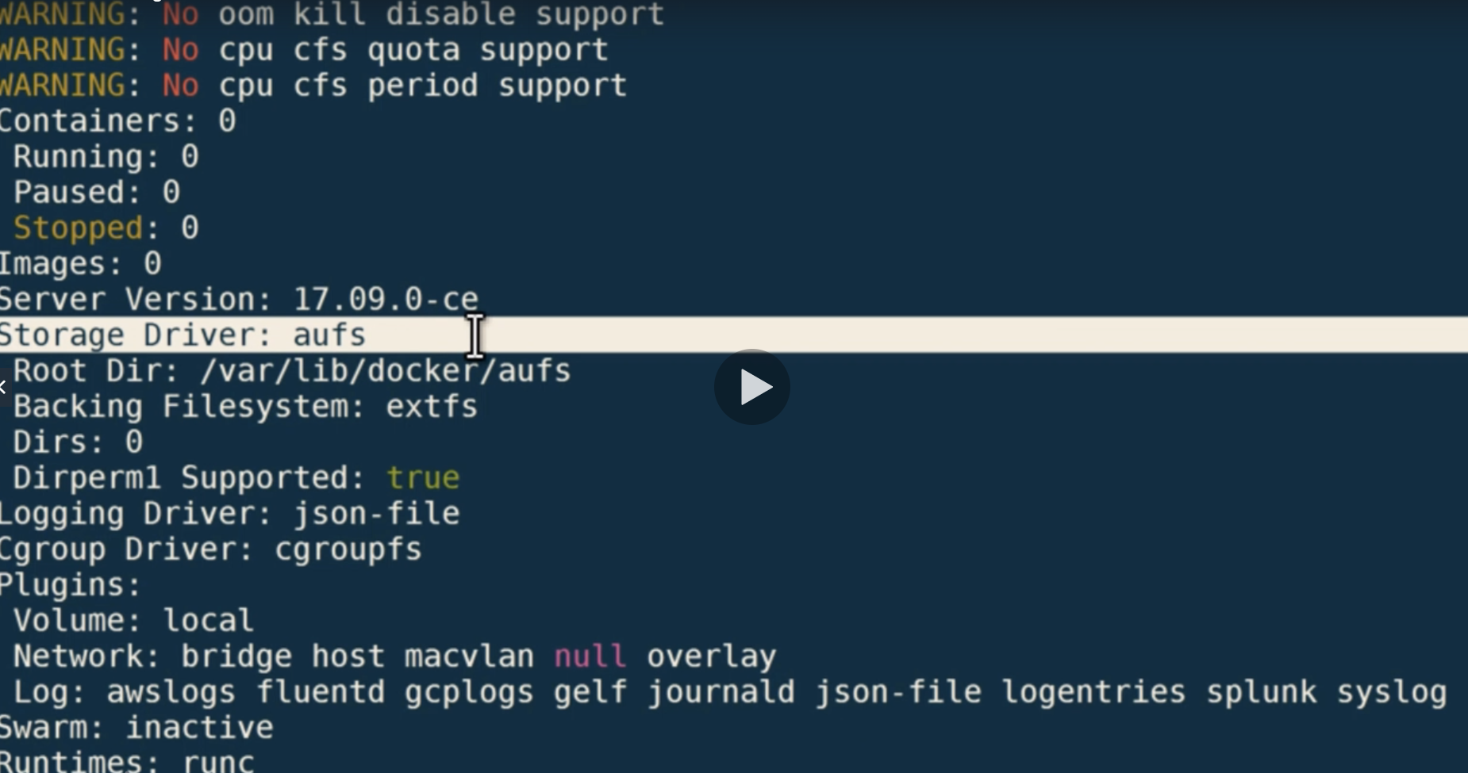

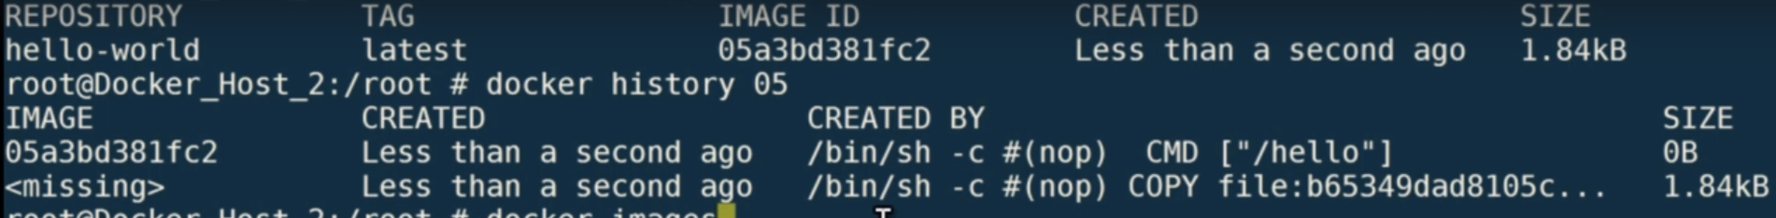

**Docker Networking**:

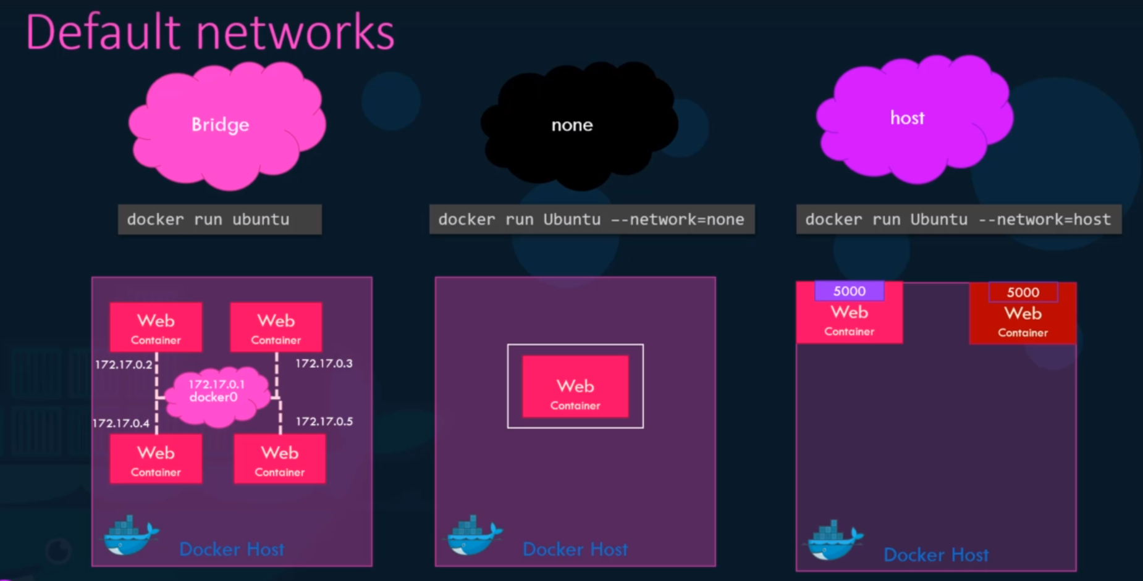

By default docker creates one bridge network, we can isolate particular group of containers by creating separate bridge network like below

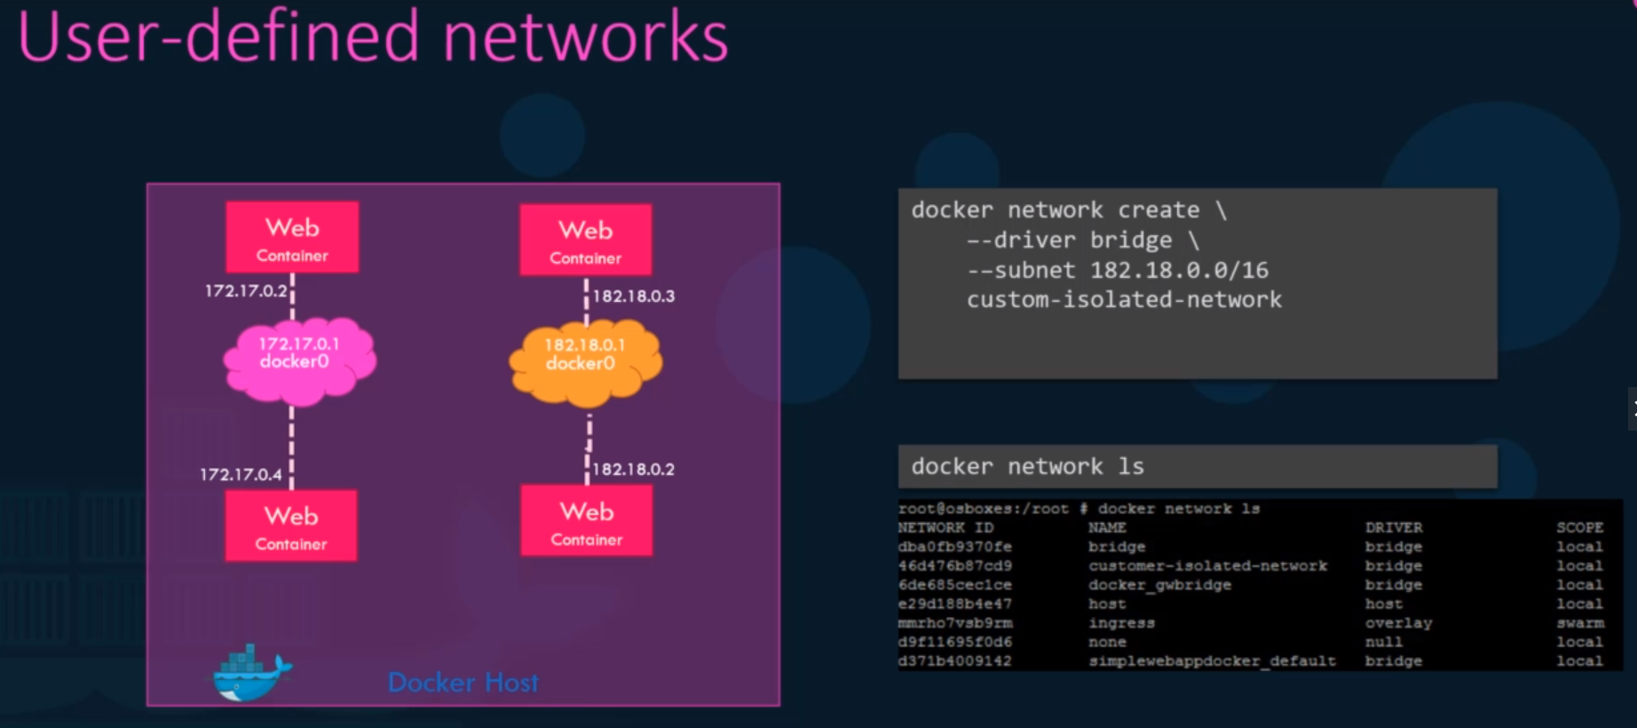

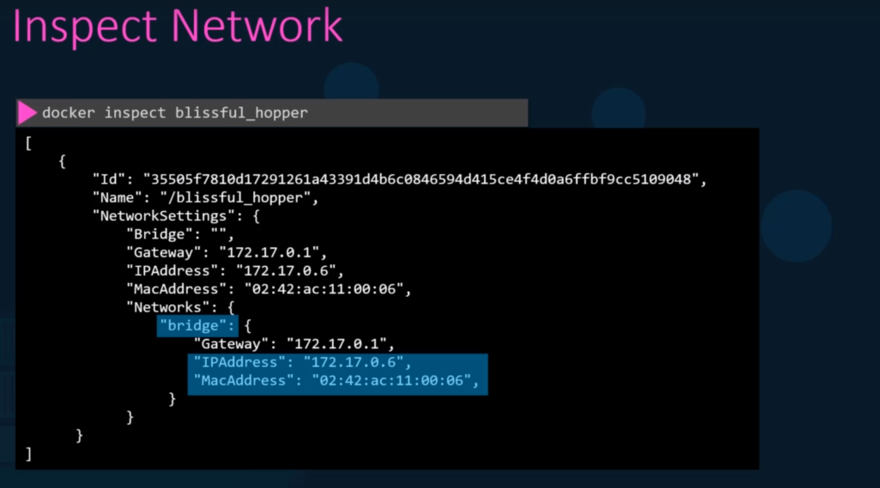

**Docker has embedded DNS system in it, containers can reach each other by its name**

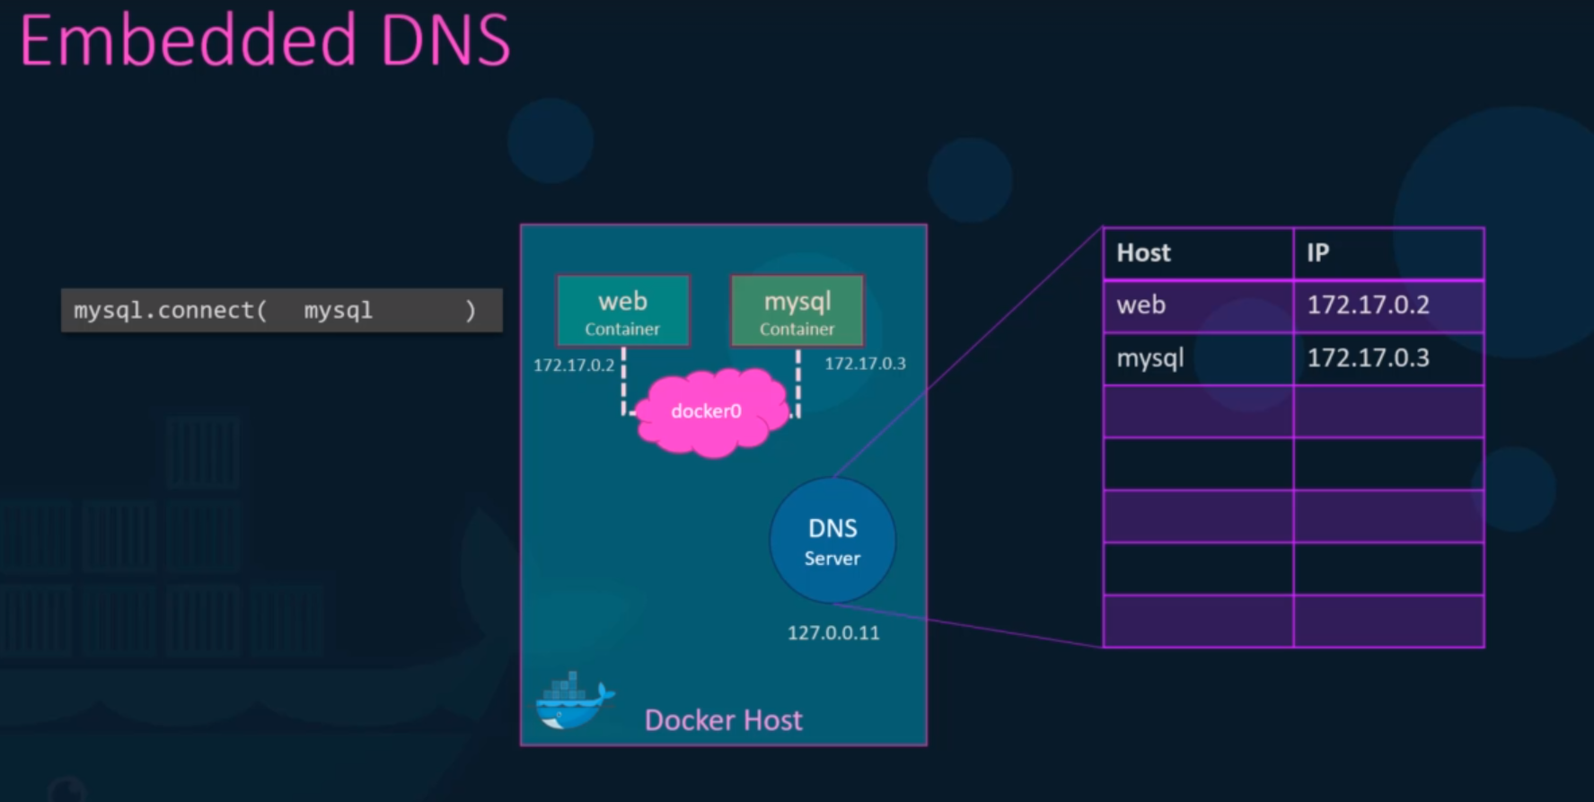

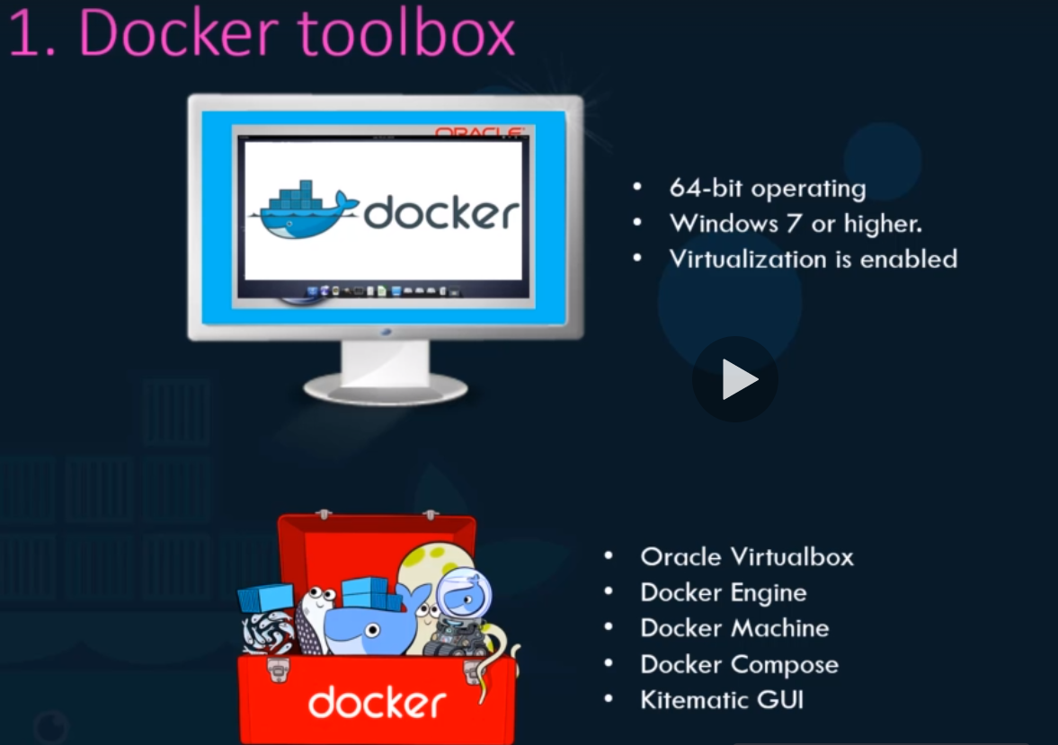

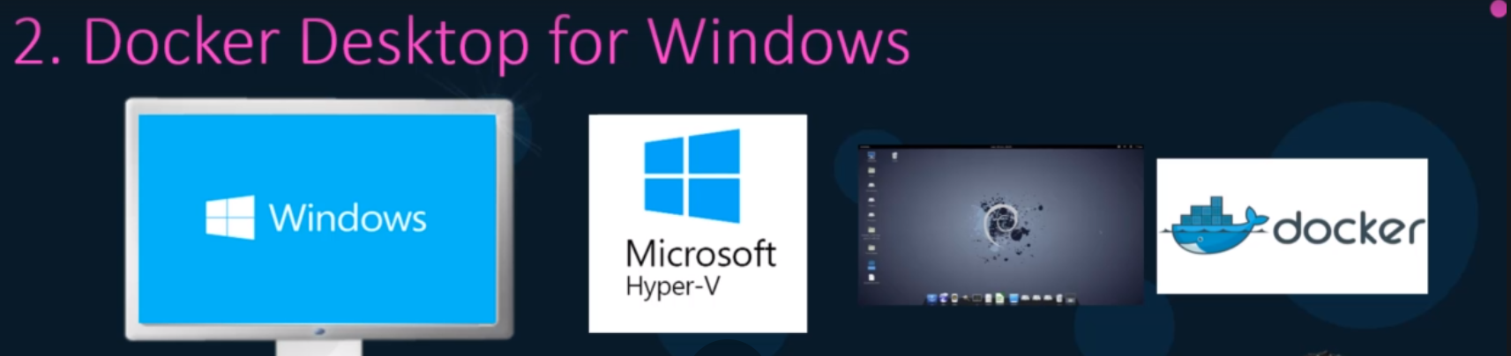

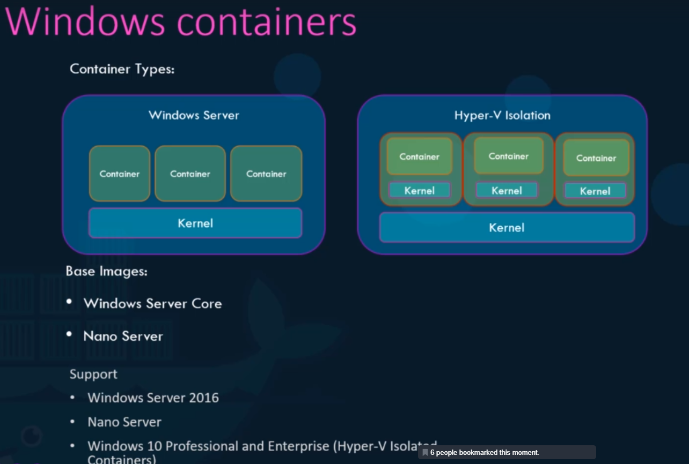

**Container Orchestration:**

Solution with set of tools and scripts than can help host containers. Using a single command, you replicate no of containers to deploy.

These solutions scale and cluster the instances’ based on load, no of requests and many more.

Advanced networking solutions between containers across different hosts.

Load balancing, sharing storage, configuration management and security.

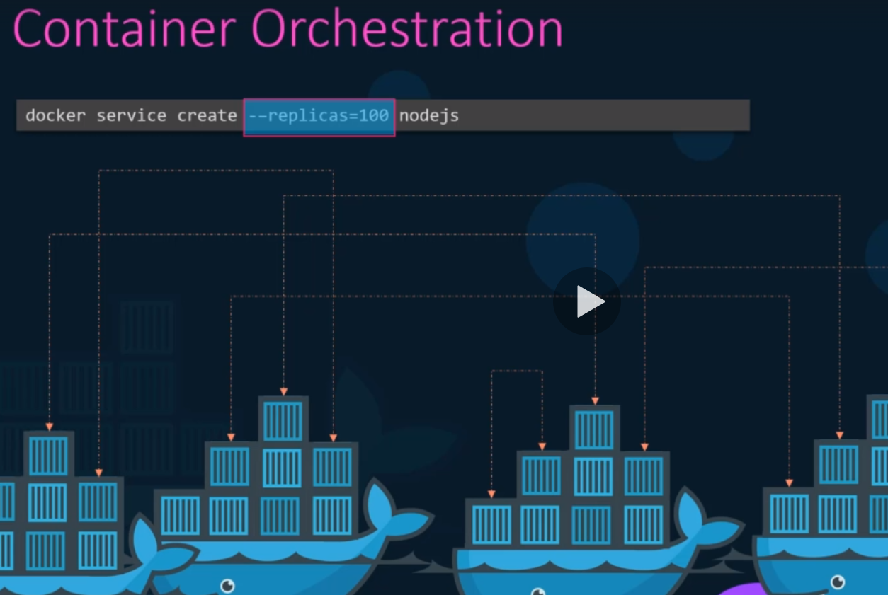

Orchestration solutions today in market:

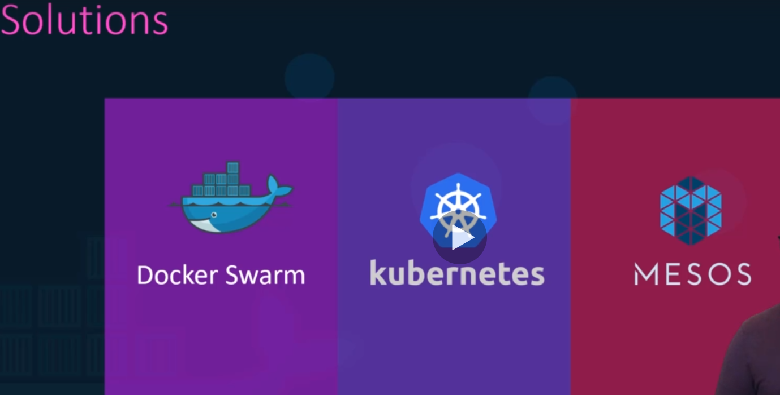

Docker Swarm:

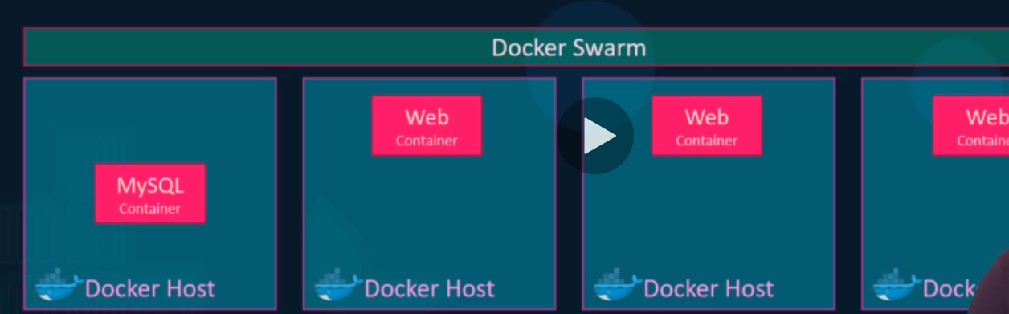

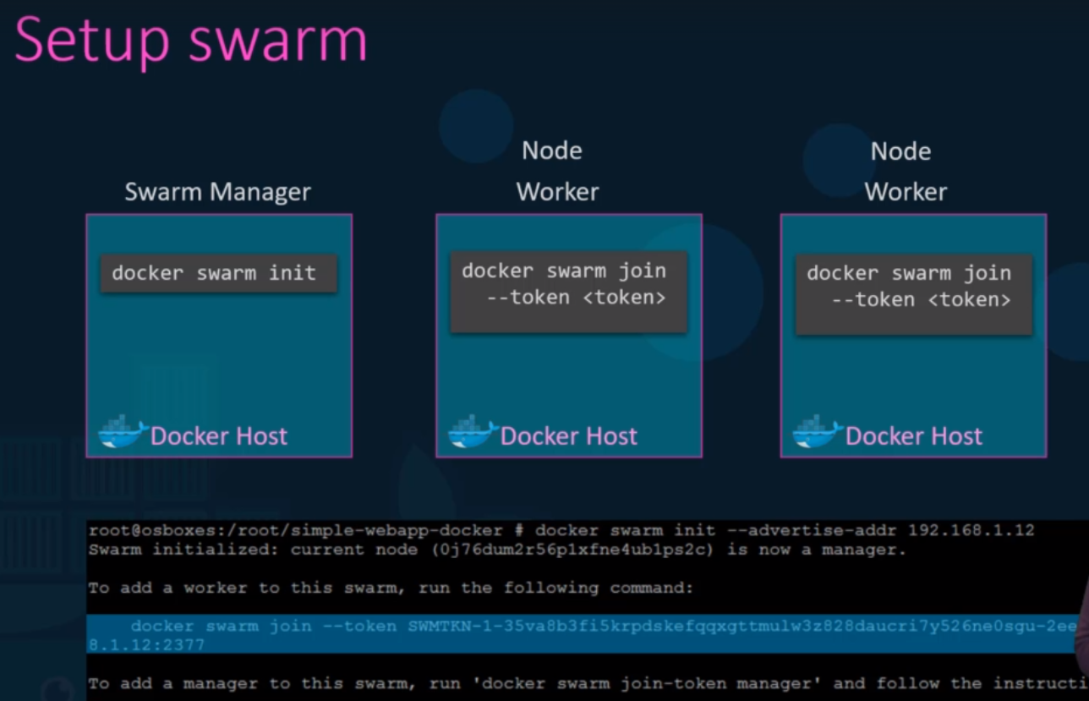

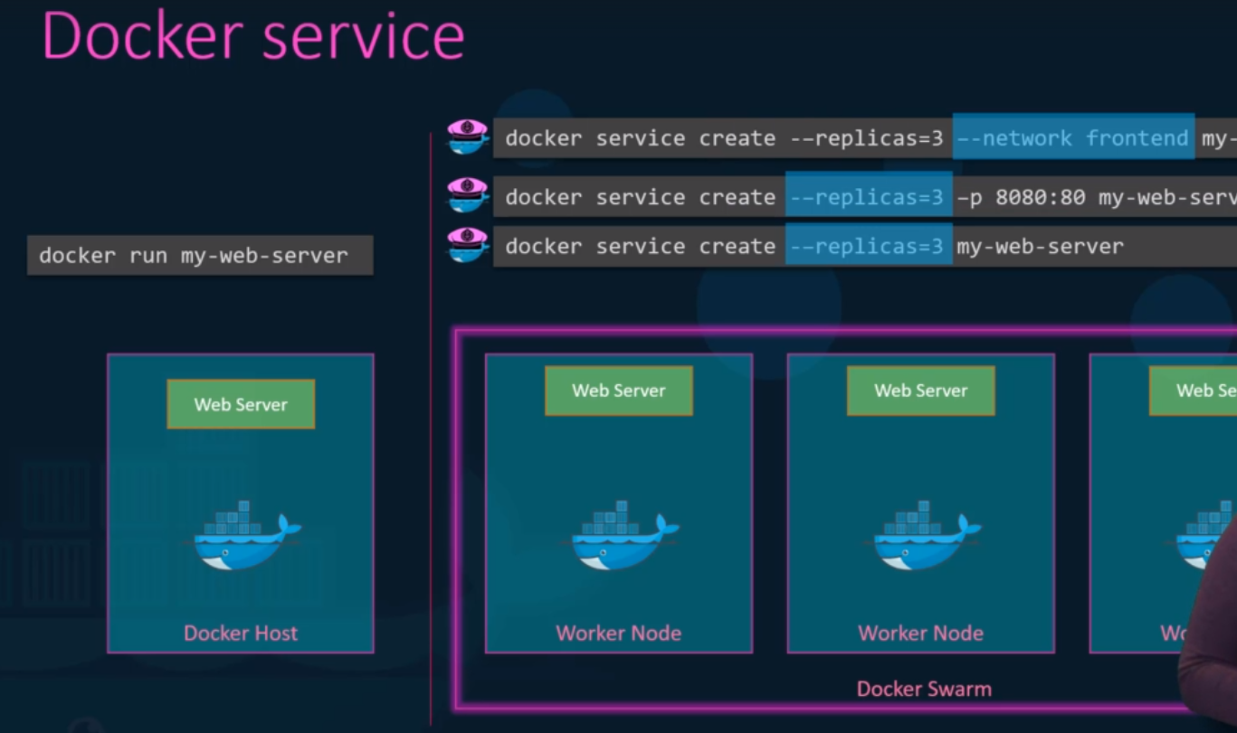

**Kubernetes**:

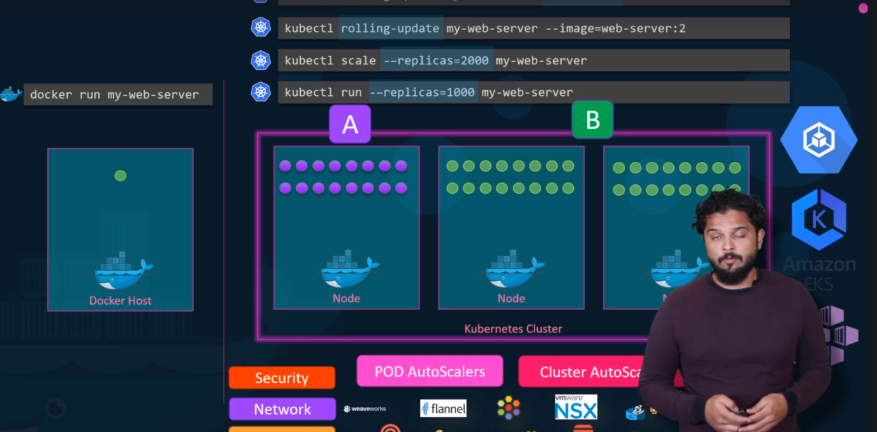

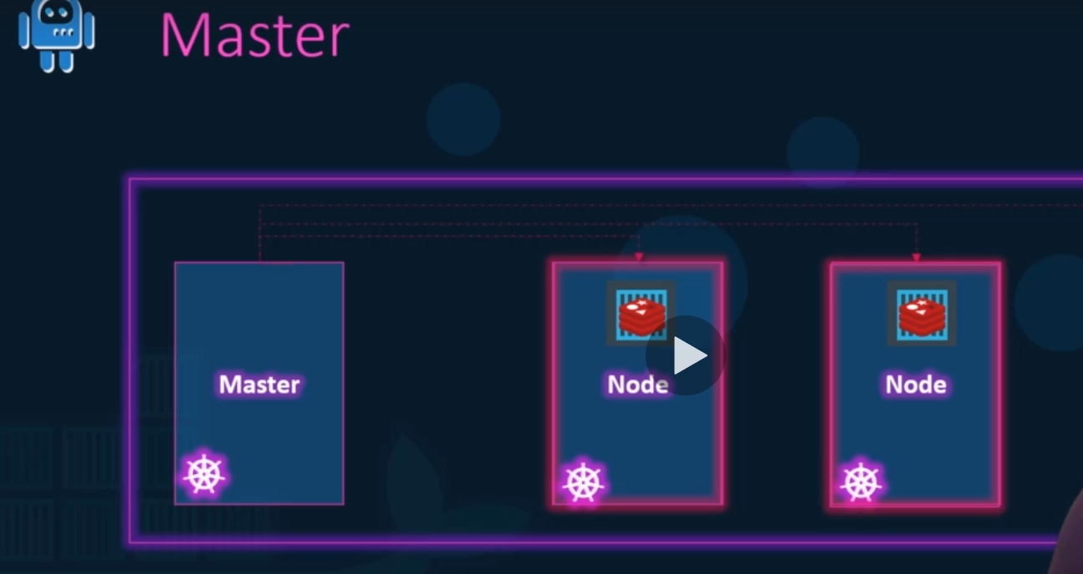

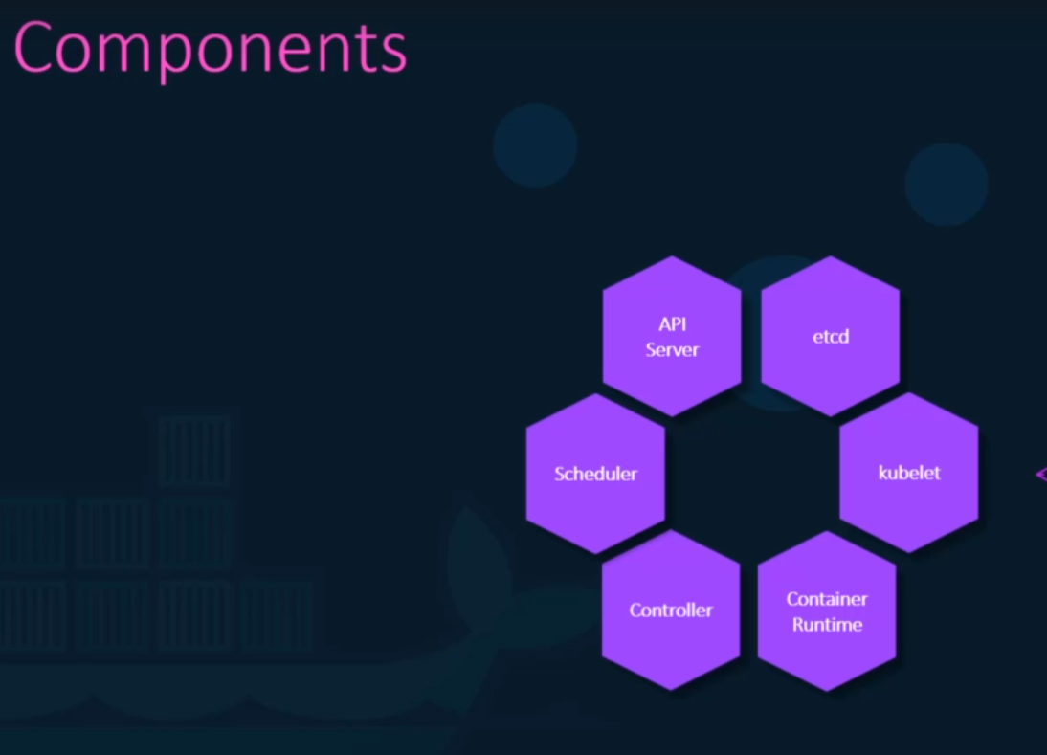

Kubectl: command line tool

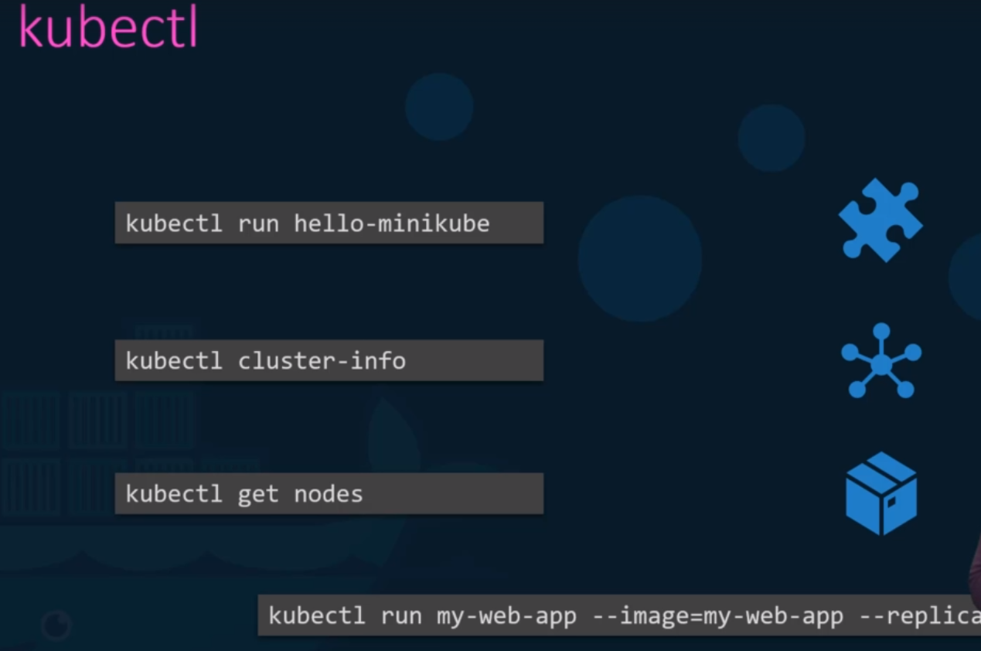

Create image without docker file:

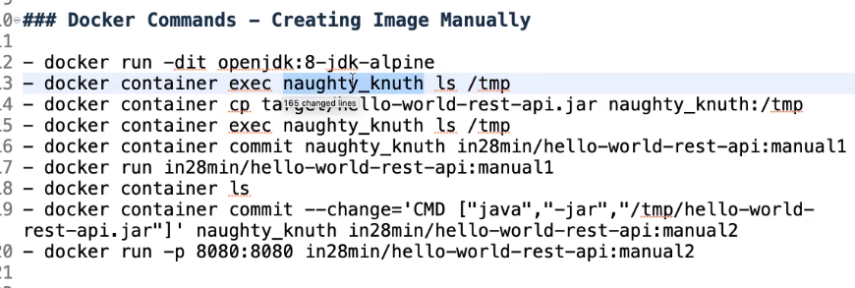

For simple Hello world Rest API

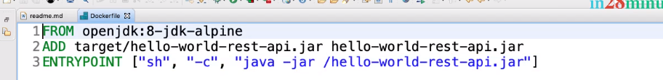

1. Can use **docker Spotify plugin** to directly create Docker Images of API by adding plugin POM file.
2. **JIB plugin**
3. **Fabric Docker Maven Plugin**

Docker commands:

docker container port <id> -- to find port mapping